Progress Report and Research Plan for BP-NGI/GRI phase II
Haosheng Huang, Dubravko Justic, Kenneth A. Rose, Chunyan Li
Project Title
Physics, Oil and Fish: Modeling the Effects of Pulsed River Diversion on Oil Transport and Fish Distribution
Objectives
Our existing NGI-BP/GRI phase I project entitled “Physics, Oil and Fish: Modeling the Effects of Pulsed River Diversion on Oil Transport and Fish Distribution” focuses on the effects of pulsed river diversions on oil transport and fish distribution. Our study site is the Breton Sound Estuary, which includes the Caernarvon Freshwater Diversion, one of the largest diversions in coastal Louisiana. Our project combines hydrodynamics (physics), water quality, individual-based fish movement, and an oil slick transport model into a single integrated “physics to fish” modeling system. We use the modeling system to examine how changes in salinity, temperature, and water quality resulting from diversions and offshore conditions affect the spatial distribution of several key fish species. The modeling system is also being used to examine if the existing Mississippi River diversions can prevent oil slicks from drifting into coastal estuaries.
Summary of Progress (August – October, 2010)
Our accomplishments during NGI-BP/GRI phase I are summarized as follows:

1) We searched various sources and collected available observational data and operational reanalysis products for the Breton Sound Estuary and the adjacent continental shelf regions. The gathered information is organized into a database of historical data and the data are used for providing forcing and initial conditions for the physics to fish modeling systems and for evaluating model performance. The main data sources include:

- Coastal sea level time series from NOAA CO-OPS (Center for Operational Oceanographic Products and Services)
- Sea level elevation, water salinity, and Caernarvon discharge rate from USGS National Water Information System
- The Mississippi River and Atchafalaya River daily discharge rate from USACE
- The 10 m above sea surface wind velocity from NOAA NOMADS (National Operational Model Archive & Distribution System)
- The ADCP current observation from LSU WAVCIS Lab
- The three-dimensional temperature and salinity distribution in the Gulf of Mexico from HYCOM forecast product (NOAA NOMADS).

2) We have implemented a high-resolution three-dimensional unstructured-grid Finite Volume Coastal Ocean Model (FVCOM) for the Breton Sound Estuary, including the Caernarvon Freshwater Diversion site and part of the Louisiana continental shelf. The model horizontal grid consists of 77,628 nodes and 145,713 triangular elements, with a variable spatial resolution of 1-10 km over the shelf regions and 20–500 m in the Breton Sound Estuary. The model includes 19 vertical sigma layers. The model grid in the estuary extends to the surrounding wetland areas to allow for wetting and drying of estuarine marshes. A time step of 0.3 seconds was used for the external mode. The Mellor-Yamada turbulence closure scheme was used to compute the vertical viscosity and diffusivity. Model prognostic variables include sea surface elevation, three-dimensional velocity, salinity and turbulent variables. Temperature was kept constant and not simulated in the present version of the model.
3) Three different numerical simulations have been run for the period from April 1 to July 1, 2010, during which the Caernarvon Diversion discharge rate was set to its maximum values (currently the real situation), to the long-term averaged value, and to zero (diversion completely turned off). Preliminary model results are encouraging. Without fine tuning of model parameters, for the real case (maximum value) simulation, simulated sea surface elevations showed good correspondence with observations on all 8 coastal sea level stations. The correlation coefficients and Index of Agreement (Willmott, 1981) were greater than 0.90 for all stations. The predicted horizontal ocean currents also compared favorably with available ADCP data. However, the salinity comparison showed relatively large error. This is probably related to an inaccurate salinity distribution assumed in the initial conditions of the simulation. The initial condition for salinity was interpolated and extrapolated from the HYCOM product. For example, the HYCOM model domain does not include the Breton Sound Estuary. Therefore, we used extrapolation to specify the initial salinity values in the estuary to be equal to the salinity at one single point in HYCOM domain that was closest to the estuary.
4) Using the simulated hydrodynamic fields, we conducted oil slick transport modeling under various hypothetical scenarios of different initial oil distribution and different Caernarvon discharge rates. In these simulations, oil is treated as particles which are made of a single substance rather than a composite of multiple hydrocarbon products. No weathering processes are considered. Therefore, simulated oil particles tended to exist longer than their real world counterparts. Preliminary numerical experiments have been run. As shown in Fig. 1, for particles released at 17:00 (GMT) April 29, 2010 (dots aligned in straight lines), when their initial locations are away from the estuary entrance (green and blue particles), the virtual oil tended to move in the northeast direction regardless of the magnitude of the Caernarvon Diversion discharge. In fact, in case of particles released at the entrance of the estuary (red particles), large diversion discharge drove the particles out of the estuary and moved them along the coastline in the northeast direction, although some particles still landed on the island inside the Breton Sound Estuary (Fig 1a). Turning off the diversion discharge allowed these particles to travel farther up into the estuary (Fig 1b). In order to draw a more concrete conclusion of the effect of river diversion on oil transport in and near the Breton Sound estuary, additional numerical experiments need to be performed with particles released at different time periods to capture varying offshore and wind conditions.

5) The individual-based fish model in which particles exhibit complicated movement behavior (i.e., smart particles) is being constructed and tested. The code for simulating behavioral movement using a kinesis algorithm has been completed and is currently being tested on a test grid. We also plan to implement an alternative movement model based on fish sensing conditions in neighboring cells and moving towards cells with the best conditions for growth and survival.
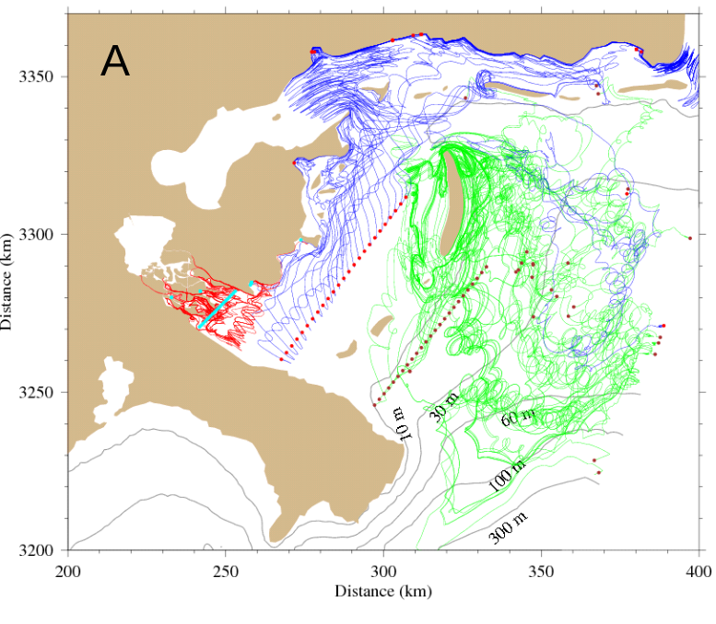
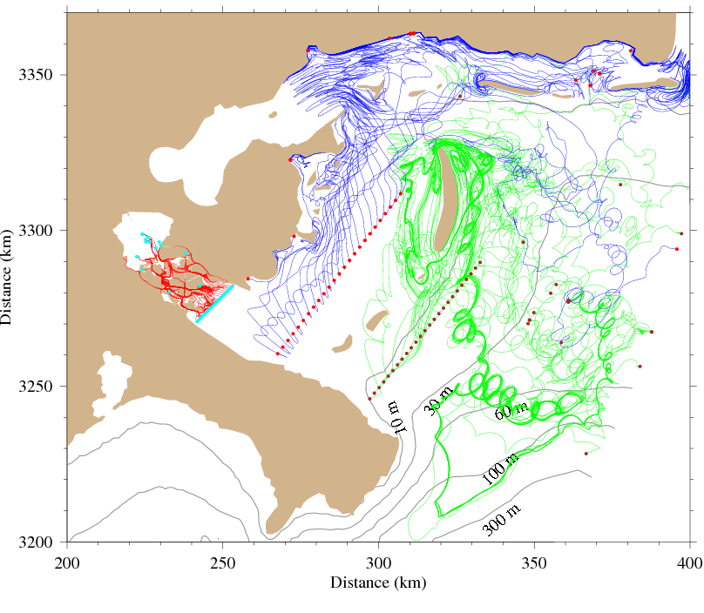
B
Fig. 1 Surface trajectories of oil particles released in and near Breton Sound Estuary at 17:00 GMT, April 29, 2010 for the scenario with Caernarvon Diversion discharge set at maximum (A) and zero discharge scenario (B). The dots are particles’ initial and final (at 00:00 GMT July 1, 2010) locations.

Research plan for BP-NGI/GRI phase II (February 2011 – December 2011)
We seek to continue our research effort in the second phase of NGI-BP/GRI. Our project is highly relevant to the study of Gulf of Mexico ecosystem, and addresses the central question of phase II “Did the Macondo 252 Oil Spill result in large scale perturbation of the NGoM ecosystem structure or function?”
The plan for future work is outlined as follows:
- Hydrodynamic model improvement: Currently, the error between observed and simulated salinity is relatively large. This is most likely due to inaccurate initial conditions, as well as incomplete external forcing that do not adequately include the effects of direct precipitation and evaporation. The hydrodynamic model simulation of salinity will be improved by the refinement of initial conditions and the addition of precipitation and evaporation effects to the forcing. The model will also be expanded to include dynamic simulation of water temperature.

- Analysis of the oil slick transport results: A more careful and detailed modeling, analysis and visualization of particle trajectories will be performed. The main questions to answer are: (a) To what extent can the existing Mississippi River diversions prevent oil slicks from drifting into the Breton Sound under various oceanic conditions, such as different wind events and tropic-equatorial tidal conditions, and (b) How large should the Caernarvon discharge rate be in order to flush oil out of the estuary?

- Continuation of the development of the individual-based fish movement model: We will implement the fitness algorithm for movement in the individual-based fish model. In addition, we will couple the fish movement model with the FVCOM hydrodynamic model. Using this fully coupled “physics to fish” modeling system, we will examine the impact of freshwater diversions and oil spills on distributions of key fish species in the Breton Sound estuary.

Ballpark cost estimation: $100 K.
Budget

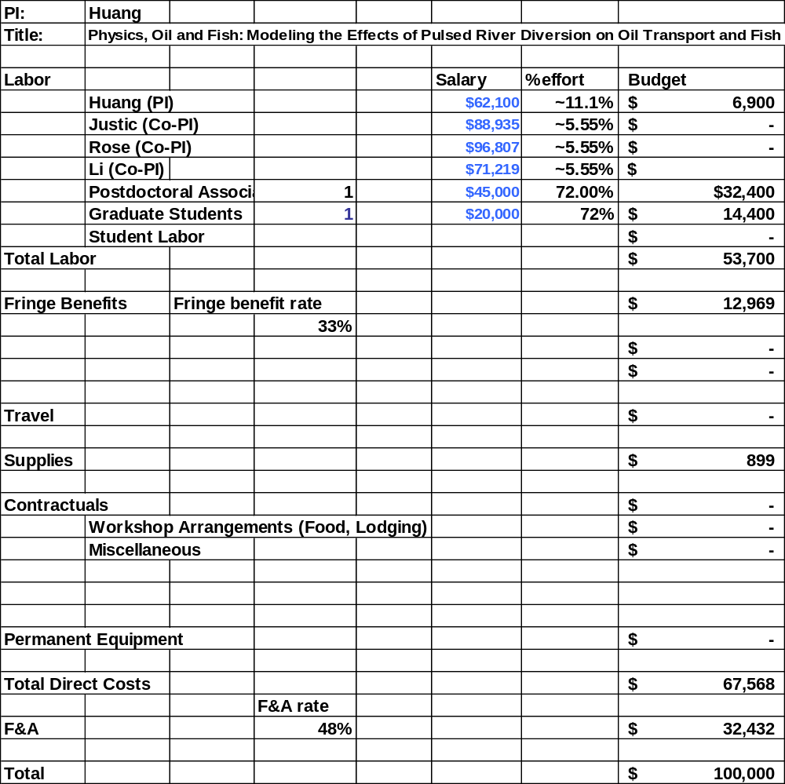

Budget justification
Senior personnel:
Principal Investigator, Dr. Haosheng Huang, Assistant Professor, Department of Oceanography and Coastal Sciences, Louisiana State University, $6,900/month, academic year appointment, 1 month support. Dr. Huang will work on hydrodynamic model development and preparation of the final report.
Co-Principal Investigator, Dr. Dubravko Justic, Professor, Department of Oceanography and Coastal Sciences, Louisiana State University, $9,882/month, academic year appointment, 0.5 month commitment to this project, no salary requested. Dr. Justic will be responsible for development of NPZ model.
Co-Principal Investigator, Dr. Kenny Rose, Professor, Department of Oceanography and Coastal Sciences, Louisiana State University, $10,756/month, academic year appointment, 0.5 month commitment to this project, no salary requested. Dr. Rose will be responsible for development of individual-based fish model.
Co-Principal Investigator, Dr. Chunyan Li, Associate Professor, Department of Oceanography and Coastal Sciences, Louisiana State University, $7,913/month, academic year appointment, 0.5 month commitment to this project, no salary requested. Dr. Li will work on hydrodynamic model development.
Postdoctoral Associate, Department of Oceanography and Coastal Sciences, Louisiana State University, $3,750/month, fiscal year appointment, 8.64 months support. Postdoctoral Associate will work on the coupling of hydrodynamic, NPZ and individual-based fish models.
Graduate Student, Department of Oceanography and Coastal Sciences, Louisiana State University, $1,667/month, fiscal year appointment, 8.64 months support. Graduate Student will work on hydrodynamic model application and individual-based fish model.
Salaries are current.
Fringe benefits:
Fringe benefits are based on LSU’s federally negotiated rate of 33%.
Supplies:
Computer supplies, $225 for each PI/Co-PI
Indirect costs:
The ICR is 48% of modified total direct costs.

