THE FLORIDA STATE UNIVERSITY
COLLEGE OF ARTS AND SCIENCES

A DIAGNOSTIC STUDY OF THE EFFECTS OF
TROUGH INTERACTIONS ON TROPICAL CYCLONE QPF

By
STEPHEN RICHARD GUIMOND

A Thesis submitted to the
Department of Meteorology
in partial fulfillment of the
requirements for the degree of
Master of Science

Degree Awarded:
Spring Semester, 2007

Copyright © 2007
Stephen Richard Guimond
All Rights Reserved

The members of the Committee approve the thesis of Stephen Richard Guimond defended on January 25, 2007.

_______________________________
Mark Bourassa
Professor Directing Thesis

_______________________________
Robert Hart
Committee Member

_______________________________
Philip Cunningham
Committee Member

_______________________________
Henry Fuelberg
Committee Member

The Office of Graduate Studies has verified and approved the above named committee members.
ACKNOWLEDGMENTS

I thank Dr. Mark Bourassa for his advice on statistical and satellite issues as well as for general encouragement throughout this work. Expertise from Dr. Robert Hart on tropical cyclone dynamics and Dr. Phil Cunningham on trough interaction details is greatly appreciated. General support from Dr. Henry Fuelberg in the early stages of this project is also recognized. In addition, discussions with John Molinari, Jeff Hawkins, Pat Harr and Deborah Hanley on different aspects greatly enhanced the quality of this work. Technical support from the Vis5D+ users group along with several scientists from UW-Madison/SSEC/CIMSS is also acknowledged. Thanks to Michelle Stewart and COAPS for their insightful comments on several aspects of this project. The author wishes to acknowledge use of the Ferret program for analysis and graphics in this paper. Ferret is a product of NOAA’s Pacific Marine Environmental Laboratory (information is available at http://www.ferret.noaa.gov). This research was supported by a NASA ocean vector winds science team grant to Mark Bourassa at COAPS, Florida State University.

TABLE OF CONTENTS
LIST OF TABLES v
LIST OF FIGURES vi
ABSTRACT ix

1. INTRODUCTION 1
Symmetric Precipitation 1
Asymmetric Precipitation 2

2. PHYSICAL MECHANISMS FOR TI INTENSIFICATION 5
Positive Influences 5
Negative Influences 8

3. DATA 10
ECMWF 10
TMPA 10
TC Best-Track 11

4. TROUGH INTERACTION DIAGNOSTICS 14
Vertical Wind Shear 14
Eddy Angular Momentum Flux Convergence (EFC) 18
Storm Compositing 19

5. RESULTS 28
Storm Case Studies 28
Composites 31

6. DISCUSSION AND CONCLUSIONS 51

REFERENCES 54
BIOGRAPHICAL SKETCH 57
LIST OF TABLES

Table 1: Changes in the mean shear vector when testing upper and lower boundaries against the basic state (i.e. 200 – 850 hPa) shear vector for all time steps (~ 420). Format is time mean ± one standard deviation. Zero azimuth line points to the North 21

Table 2: Summary of shear vector boundary sensitivity ratios analyzed through changes in mean maximum precipitation. Values are computed according to (5) and are expressed in %. Format is radial mean ± one standard deviation for each storm quadrant; down-shear left (DSL), down-shear right (DSR), up-shear left (USL), up-shear right (USR) 22

Table 3: List of storms used for composite analysis along with summary of dynamic and thermodynamic components. The latitude represents the TC center position at TI initiation time while the EFC, shear and MSE potential are expressed as a mean over the 24-hour period following TI initiation 23

LIST OF FIGURES

Figure 1: Histogram comparing 3-hourly 0.5° by 0.5° rain rates from the Kwajelein radar (blue) with coincident values from the TMPA research product (red) in 2001. Taken from Huffman et al. (2006) 13

Figure 2: Summary of the sensitivities of differing upper (tropopause) and lower (surface, 925 hPa) shear vector boundaries on the mean maximum (over time) precipitation differences computed according to (4) in mmhr⁻¹ for all storms. Values are displayed in the four quadrants formed by the shear vector with the gray swath depicting the standard error of the mean for the tropopause 25

Figure 3: Same as in Fig. 2, only computed as a ratio shown in (5) and expressed as a percentage 26

Figure 4: Microwave satellite data availability, up to the present day, used in the TMPA 27

Figure 5a: Time series of EFC [(ms⁻¹) day⁻¹] on the dynamic tropopause for Hurricane Kate (2003). Red line denotes the time of TI initiation while the blue dashed line marks the 10 (ms⁻¹) day⁻¹ threshold used for determining TIs 36

Figure 5b: Time series of vertical wind shear (Dynamic Tropopause — 850 hPa; ms⁻¹) for Hurricane Kate (2003). The red line has the same definition as in Fig 5a 37

Figure 5c: Vis5D three-dimensional iso-surface of PV (0.8 PVU) for Hurricane Kate (2003) at the time of TI initiation (1800 UTC 28 September). ECMWF winds are overlaid on the surface for visual interpretation. The iso-surface is colored by relative humidity with warm and cool colors denoting dry and moist air, respectively 38

Figure 5d: Radius-time plot of precipitation (mmhr⁻¹) in the four-quadrants of Hurricane Kate (2003). The red line has the same definition as in Fig. 5a 39

Figure 5e: Precipitation enhancements (black dashed line) in the four-quadrants of Hurricane Kate (2003). The mean precipitation in the 24-hours before and after TI initiation is shown in the blue and red lines, respectively with the thin black line displaying the zero line. All values are expressed in mmhr⁻¹ 40

Figure 6a: Same as in Fig. 5a, only for Hurricane Alex (2004) 41

Figure 6b: Same as in Fig. 5b, only for Hurricane Alex (2004) 42

Figure 6c: Vis5D three-dimensional iso-surface of PV (1.1 PVU) for Hurricane Alex (2004) interpolated to the time of TI initiation (2100 UTC 2 August). All other plot details can be found in Fig. 5c 43

Figure 6d: Same as in Fig. 5d, only for Hurricane Alex (2004) 44

Figure 6e: Same as in Fig. 5e, only for Hurricane Alex (2004) 45

Figure 7: Composite mean (N=12) precipitation enhancements (thick black line). The blue and red lines depict the mean rain rates in the 24 hours before and after TI initiation, respectively. The gray swath shows the standard error of the mean enhancements and the thin black line displays the zero line. All values are expressed in mmhr⁻¹ 46

Figure 8: Sensitivity of TI timing on the composite mean precipitation enhancements (mmhr⁻¹) in the down-shear left quadrant 47

Figure 9: Storm sample number as a function of shear magnitude threshold (ms⁻¹) used for computing statistics on EFC, MSE potential and precipitation in subsequent figures 48

Figure 10: Scatter plot relating shear magnitude threshold (ms⁻¹) and maximum mean precipitation enhancement (mmhr⁻¹) in the composite down-shear left quadrant. Storm sample numbers can be found in Fig. 9. Linear regression equation with uncertainties is shown in (7) 49

Figure 11: Scatter plot relating the maximum mean precipitation enhancements (mmhr⁻¹; red text) in the composite down-shear left quadrant to the shear magnitude threshold (ms⁻¹), mean EFC [(ms⁻¹) day⁻¹] and MSE potential (KJkg⁻¹). Green text is the standard error of the mean (mmhr⁻¹) reported at the location of the precipitation maximum. Storm sample numbers can be found in Fig. 9 50

ABSTRACT
A composite study analyzing the influence of upper-tropospheric troughs on the evolution of precipitation in 12 Atlantic tropical cyclones (TCs) between the years 2000 – 2005 is presented. The TRMM Multi-Satellite Precipitation Analysis (TMPA) is used to examine the enhancement of precipitation within a 24-hour window centered on trough interaction (TI) time in a shear-vector relative coordinate system. Eddy angular momentum flux convergence (EFC) computed from European Centre for Medium-Range Weather Forecasts (ECMWF) operational analyses is employed to objectively determine the initiation of a TI while adding insight, along with vertical wind shear, into the intensification of TC vortices. The relative roles of the dynamics (EFC and vertical wind shear) and thermodynamics (moist static energy potential) in TIs are outlined in the context of precipitation enhancement that provides quantitative insight into the “good trough”/“bad trough” paradigm.
The largest precipitation rates and enhancements found in the down-shear left quadrant of the storm, consistent with previous studies of convective asymmetries. Maximum mean enhancement values of 1.4 mmhr⁻¹ are found at the 200 km radius in the down-shear left quadrant. Results indicate that the largest precipitation enhancements are found to occur with “medium” TIs; comprised of EFC values between 17 – 22 (ms⁻¹ ) day⁻¹ and vertical wind shear < 12.0 ms⁻¹ along with a generally positive moist static energy potential.
Sensitivity tests on the upper vertical wind shear boundary reveal the importance of using the tropopause for wind shear computations when a TC enters mid-latitude regions. Changes in radial mean precipitation ranging from 29 – 40 % across all storm quadrants were found when using the tropopause as the upper boundary on the shear vector. Tests on the lower boundary using QuikSCAT ocean surface wind vectors exposed large sensitivities on the precipitation ranging from 42 – 60 % indicating that the standard level of 850 hPa, outside of the boundary layer in most storms, is more physically reliable for computing vertical wind shear. These results should help to improve TC quantitative precipitation forecasting (QPF) as operational forecasters routinely rely on crude statistical methods and rules of thumb for forecasting TC precipitation.
CHAPTER 1

INTRODUCTION

Tropical Cyclones (TCs) are the most destructive storms on Earth producing large loss of life, injuries and billions of dollars in damage to homes and businesses on a yearly basis. Although fierce winds surrounding the TC core account for a significant percentage of the damage, inland flooding due to storm surge and intense, long-lived rainfall is responsible for the largest loss of life with these systems (Rappaport 2000). Extreme precipitation within TCs is not uncommon as noted by Elsberry (2002) when a rain gauge measured 36.71 in. as Hurricane Danny (1997) slowly made landfall. The intensity of precipitation within a TC is directly related to convective activity, which is a difficult parameter to forecast due to the complex, rapid changes in the internal dynamics of the storm as well as interactions with the surrounding environment. As TCs move out of the tropics (20° N/S) and into the middle latitudes, the complexity of internal and environmental interactions increases mainly due to sharp gradients in oceanic thermal structure and the approach of upper-tropospheric troughs embedded in the westerly flow. As a result, forecasting precipitation amounts becomes increasingly difficult with the potential for dire consequences. For example, the interaction of Hurricane Floyd (1999) with a mid-latitude trough resulted in almost 60 deaths with North Carolina exceeding 100-yr flood levels; this case was more complicated due to Floyd’s interaction with a coastal front and subsequent extratropical transition (Elsberry 2002). It is clear that continued research into TC quantitative precipitation forecasting (QPF) in all phases of the storm structure is needed.

1.1 Symmetric Precipitation

Previous studies of the symmetric structure of TC precipitating convection (Frank 1977; Rodgers and Adler 1981; Marks 1985; Burpee and Black 1989) have highlighted the role of intense eyewall convection as the dominant mode of precipitation production with a generally even azimuthal distribution surrounding the storm core, although variations in the quadrant location of the maximum rainfall have been reported. In the airborne radar study by Marks (1985), mean azimuthal rain rates in the eyewall of Hurricane Allen (1980) were found to be 11.3 mmhr⁻¹, six times that of the mean in the radial band between the eyewall and 111 km where strong radial gradients in reflectivity were observed. A land based radar study of Hurricanes Alicia (1983) and Elena (1985) by Burpee and Black (1989), found azimuthal mean eyewall rain rates of 5.2 and 6.0 mmhr⁻¹, respectively with a ~ 50% reduction of mean precipitation in the radial band between the eyewall and 75 km radius. Lonfat et al. (2004) analyzed the precipitation distribution of 260 TCs stratified by intensity and oceanic basin using the Tropical Rainfall Measuring Mission (TRMM) Microwave Imager (TMI). They found that mean azimuthal rain rates for all storms in the Atlantic basin maximized at over 5.0 mmhr⁻¹ within 50 km from the TC center with a linear decrease to 1.0 mmhr⁻¹ at the 350 km radius. Storms in categories 1-2 and 3-5 displayed a peak in mean azimuthal rain rate of ~7.0 and 12.0 mmhr⁻¹, respectively at the 35 km radius. The mean rain rate from all classes of intensity maximized at 5.0 mmhr⁻¹ at the same radial distance. These studies imply that the symmetric precipitation distribution in the eyewall region of TCs can fluctuate significantly from one storm to the next due to varying internal and environmental dynamics, with the mean core region (≤ 50 km) precipitation encompassing a 5.0 – 12.0 mmhr⁻¹ range.

1.2 Asymmetric precipitation

Recent studies of the asymmetric distribution of precipitation have been primarily model based and qualitative in nature with a focus on the effects of vertical wind shear in producing convective/precipitation asymmetries. Using 5 km resolution, fully explicit moist physics simulations, Frank and Ritchie (2001) found wavenumber one asymmetries in the upward motion and rainfall fields with maximum concentration to the left of the shear vector for shear magnitudes between 5 – 15 ms⁻¹. The cloud water and rainfall fields were found to respond quickly to the application of vertical wind shears beginning at 5 ms⁻¹. Rogers et al. (2003) used 1.67 km inner grid spacing with a similar explicit moist convection scheme on the fine mesh as in Frank and Ritchie (2001) to simulate Hurricane Bonnie (1998). They found that when the shear was large (20 – 25 ms⁻¹), the strongest convection in the core was generally located in the down-shear left quadrant of the storm, in agreement with Frank and Ritchie (2001). In addition, Rogers et al. (2003) found that the accumulated precipitation was sensitive to the storm motion, with a more symmetric structure about the storm track when the shear was strong and directed across track and more asymmetric when the shear was weak and along track. The satellite analysis of Lonfat et al. (2004) found that the maximum asymmetric rainfall, determined from Fourier decomposition, was located in the front quadrants in a storm-relative coordinate system, with a shift in location from the left-front quadrant for a tropical storm to the right-front quadrant for stronger (category 3-5) systems. In addition, the rainfall asymmetry was found to fluctuate with intensity as tropical storms were found to have a larger asymmetry than the stronger more organized category 1-5 hurricanes. There are very few studies of the precipitation structure during TC trough interactions most likely due to the focus on understanding intensity change and the previously inadequate observation network. Rodgers et al. (1994) used precipitation estimates from the Special Sensor Microwave/Imager (SSM/I) to analyze the environmental influence on the spatial and temporal changes of rainfall in three North Atlantic hurricanes. The SSM/I measurements were found to detect the timing and movement of convective ring cycles (high precipitation rates), such as those described in Willoughby et al. (1982), well with reasonable correlations to intensity change. Although only two cases of TC trough interaction were found, evidence for a link between eddy angular momentum flux convergence, due to an approaching mid-latitude trough, and excitation of a convective ring cycle was established. The new precipitation dataset described in section 3.2 will help to alleviate previous observational limitations and provide a fresh look at the problem of TC QPF.
Although, the studies mentioned above have greatly improved our understanding of TC precipitation structure, large errors still exist in the forecasting of rainfall associated with land falling TCs (Elsberry 2002). Rogers et al. (2003) notes that model biases are common in numerical simulations of TCs reflecting the limitations of initialization and in particular parameterizations of microphysics, which play a crucial role in precipitation processes. Elsberry (2002) revealed that several scientists have reservations on the accuracy of numerical model guidance in TC QPF based primarily on microphysical uncertainties and track prediction accuracy. Thus, model derived precipitation can currently only provide qualitative guidance towards a solution to the problem of TC QPF. However, scientists at a recent symposium on precipitation extremes revealed that with more frequent, higher quality data assimilation of microwave satellite data, numerical models could improve TC QPF significantly (Elsberry 2002). In addition to numerical model guidance, operational forecasters routinely rely on Rainfall CLImatology and PERsistence statistics (R-CLIPER) as well as information on storm speed and size (“Kraft rule of thumb”) to predict TC precipitation (Lonfat et al. 2000; DeMaria and Tuleya, 2001). These sources of guidance have obviously large flaws inherent within them. For example, TC precipitation displays large storm-to-storm variability (as outlined earlier in this section) that cannot be captured by a general climatology. Furthermore, the most recent R-CLIPER system was developed using the statistics compiled by Lonfat et al. (2004), which relied on data from the TMI. The TMI has very limited space and time coverage in mid-latitudes and thus the R-CLIPER will not include the effects of trough interactions. The “Kraft rule of thumb” has no basis on observations or storm dynamics and thus can only provide a very crude estimate of TC precipitation.
The goal of this study is to advance the understanding of TC precipitation structure in mid-latitudes with a focus on trough interactions (TIs). Vertical wind shear and eddy angular momentum fluxes (dynamic component) as well as moist static energy (MSE) potential (thermodynamic component) will be used to analyze the effects of environmental forcing on TC precipitation structure. The results of this paper are intended to assist operational forecasters with observationally based, quantitative guidance grounded in dynamical processes that will improve TC QPF in mid-latitudes.

CHAPTER 2

PHYSICAL MECHANISMS FOR TI INTENSIFICATION

Although different dynamical theories exist to explain the deepening of a TC during a TI, the main goal of describing the enhancement of the secondary (radial-vertical) circulation is common to all of them. Several previous authors (e.g. Pfeffer and Challa 1981; Holland and Merrill 1984; Molinari and Vollaro 1989) analyzed eddy angular momentum fluxes to explain the intensity change observed during environmental interactions with TCs. Molinari et al. (1998) and Hanley et al. (2001) focused on TC intensity change from a potential vorticity (PV) perspective. There are positives and negatives in using either angular momentum or PV arguments. Eddy angular momentum flux convergence (EFC) provides a concise manner of identifying when TIs have taken place. In addition, the intensity of TIs can be examined by analyzing the momentum source from the trough and TC outflow although potentially important details on the role of eddy heat fluxes during intensification are not included (DeMaria et al. 1993). Using PV thinking allows the combination of eddy momentum and heat fluxes when analyzing TIs, but no method currently exists for identifying TIs objectively (Molinari et al. 1998; Hanley et al. 2001). In this study, EFC is used primarily as a method to define the timing of TI initiation similar to DeMaria et al. (1993) and Hanley et al. (2001). The magnitude of the EFC is used as a means to explain the spin-up of the TC vortex and the enhancement of precipitation.

2.1 Positive Influences

The authors above have implied several possible mechanisms for TI intensification: (1) enhanced anti-cyclonic outflow near the height of the tropopause due to confluence between the approaching trough and TC (Holland and Merrill 1984). This process leads to a large mass evacuation at upper levels over the storm core, which in turn requires radial inflow and an upward mass flux to maintain conservation; (2) associated with the confluence region of the approaching trough and TC are quasi-geostrophic type arguments for induced upward motion, including (i) increasing cyclonic vorticity advection with height and (ii) location of the TC core within the left front or right rear jet streak quadrants and (3) restoration of thermal wind balance expressed as

(1)

where is potential temperature, is the radius from the TC center, is angular momentum and is tangential velocity (Molinari and Vollaro 1989). Before TIs, is largely negative as is expected in a warm-core system, but as the approaching trough imports cyclonic angular momentum into the TC volume, approaches zero and thus adjusts by inducing adiabatic cooling (ascent) in the core and adiabatic warming (descent) at outer radii. This pattern of vertical motion leads to increased convection within the core and the formation of a reservoir of diabatic heating aloft, thus hydrostatically reducing the surface pressure.
There are two necessary conditions for the above processes to provide for sustained convection and rapid deepening of the storm. First, there must be net heating within the column of air in the TC core. If the inertial stability of the vortex is too low, the induced adiabatic cooling will be widespread and thus overpower the warming from latent heat release (Schubert and Hack 1982). Therefore, it is proposed that a sufficient amount of cyclonic absolute vorticity in the lower to mid-tropospheric vortex already needs to be in place in order for the convective heating to outweigh adiabatic cooling. As a result, net heating within the vortex leads to lowered surface pressure and a more efficient TI. In the TC outflow layer, inertial stability is at its lowest, allowing eddy angular momentum fluxes from an approaching mid-latitude trough to enter the TC volume. A decrease in inertial stability in the outflow layer would allow for greater separation between the trough and TC during a TI. Although the EFC may be reduced by this separation, it would provide for a minimization of the effects of vertical wind shear which can have a strong influence on the intensification process (DeMaria et al. 1993; Hanley et al. 2001).
The second necessary condition, following WISHE theory (Emanuel 1986), is an adequately warm ocean to supply heat fluxes that will maintain convection after the initial ascent is induced. Most previous authors have considered the effects of sea surface temperature (SST) during a TI in a rather simplistic manner. DeMaria et al. (1993) used SSTs in a multiple regression technique (including vertical wind shear) to find a relationship between EFC and TC intensity change. Rodgers et al. (1994) employed a synoptic description of SSTs under three TCs in the Atlantic basin to comment on the structure of convection and precipitation within each system. In their TI composite study, Hanley et al. (2001) considered ocean heat support by only considering storms with SSTs > 26ºC. Although SSTs are a widely used metric for determining the ocean’s role in a TC, they only provide a one-dimensional picture of the heat flux, namely the surface, which can result in inaccurate inferences on the thermal support of the storm. In addition, SSTs only provide direct information on the surface component of the sensible heat flux, with an indirect contribution to the derived near-surface specific humidity and latent heat flux. It was found, from an independent analysis of data taken from Morey et al. (2006), that the mean sensible heat flux can be roughly an order of magnitude less than the mean latent heat flux (~80 and 800 Wm⁻², respectively) within the core of Hurricane Dennis (2005) during its movement across the Gulf of Mexico. Thus, in order to examine the role of total (sensible and latent) oceanic energy in the TI process, moist static energy (MSE) differences between the surface and 10m are computed. Moist static energy can be expressed as

(2)

where $C_{p}$ is the specific heat of water vapor at constant pressure, $T$ is the temperature (SST for surface), $F$ is the geopotential, $L$ is the latent heat of vaporization and $w$ is the mixing ratio (determined as 98% of saturation with the SST for surface values; Morey et al. 2006). The MSE differences act as a measure of the potential energy flux available to the storm requiring only wind velocity to release the energy into the system. Given a significant MSE difference beneath the storm core, a spin-up of the incipient vortex during a TI will release large amounts of energy into the air, helping to fuel convective growth. Low MSE differences (hereafter MSE potential) reflect minimal thermal support to the storm and in theory, results in weaker, short-lived convection. The MSE potential used in analyzing the precipitation enhancement of TI cases and presented in section 5 is computed as a mean over space (100 km radius from TC center) and time (24-hours after TI initiation).

2.2 Negative influences

Along with low oceanic thermal support to the storm as mentioned in the previous section, strong vertical wind shear plays the largest role in the weakening of a TC (Gray 1968; DeMaria and Kaplan 1994; Frank and Ritchie 1999, 2001). In general, the physical mechanisms explaining the effects of vertical wind shear on the core of a TC are well known, although some disputes on the precise methods of vortex spin-down are evident in the literature. Gray (1968) and more recently Frank and Ritchie (1999, 2001) determined that vertical wind shear acts to tilt the vortex down-shear, allowing for advection of the upper level warm anomaly away from the TC center. The displacement of the heating aloft acts to ventilate the upper troposphere while decoupling the lower tropospheric frictional convergence with the mid-level latent heat release leading to increased surface pressures. DeMaria (1996) in his simple two-layer balance model suggests that convective inhibition occurs as a result of tilting the TC PV anomaly away from the center of the storm. Mid-level warming is required to balance the mass field as a result of the tilted PV structure, which suppresses deep convective activity and stabilizes the vortex. Although the theories of Gray (1968) and DeMaria (1996) are different, the main physical results are the same. Specifically, the tilt of the vortex during strong vertical wind shear produces persistent wavenumber one asymmetries in the vertical motion, convection and precipitation fields with maximum activity in the down-shear left quadrant of the storm (Frank and Ritchie 1999, 2001; Reasor et al. 2000; Corbosiero and Molinari 2002).
When an upper-tropospheric trough approaches a TC, large values of vertical wind shear are typically observed over the storm volume (Hanley et al. 2001). However, along with increased vertical wind shear come the complicated and competing effects of intense, inward propagating eddy angular momentum fluxes. Thus, the issue of whether a TI will intensify or weaken a TC comes down to the relative roles of the positive effects of EFC and the negative effects of vertical wind shear along with oceanic energy support, which depending on the magnitude, can be viewed on either side of the issue. In theory, to maximize the potential for intensification, a TC would need to minimize the vertical wind shear (negative effects) while maximizing the EFC and MSE potential (positive effects). Previous studies have noted the importance of PV scale matching between the trough and TC that enables shear to be reduced while still providing the TC with eddy PV fluxes necessary for intensification (Molinari et al. 1995, 1998). Scale matching occurs when deep convection in the core of a TC diabatically lifts the tropopause while building the ridge downstream. The result of this process is an enhancement of the outflow anti-cyclone and a decrease in the horizontal scale of the trough that approaches the scale of the TC vortex. The three-dimensional PV structure for two case studies presented in section 5 elucidates the scale-matching process and tilt of the TC vortex described in this section. In addition, section 5 also links specific ranges of values from the competing effects of vertical wind shear and EFC as well as MSE potential to precipitation enhancement during TI cases.

CHAPTER 3

DATA

3.1 ECMWF

Six-hourly, 1.125º European Centre for Medium-Range Weather Forecasts (ECMWF) operational analyses were used for computations of vertical wind shear and EFC. Molinari et al. (1992) found that the tangential velocity (vorticity) of ECMWF data was more accurate than the radial velocity (divergence) through a comparison of two TC case studies. Although quantitatively, there were some discrepancies between the model velocities and the observational control, the qualitative structure of both fields remained quite reliable. In addition, Molinari et al. (1992) found that eddy angular momentum fluxes and the related EFC suffered some errors, but were almost quantitatively similar to the control, mimicking major events, such as TIs, well in terms of timing and location. DeMaria et al. (1993) notes that EFC values are found to increase by a factor of three or more during a TI indicating that the signal for these changes is much larger than the random errors; therefore EFC can be used with confidence to distinguish TI events. However, while it is found here that this argument is true for TI initiation times, it is more difficult to distinguish TI termination times largely due to the TC’s diabatic erosion of the PV anomaly associated with the trough (Molinari et al. 1995, 1998). To avoid the complexities associated with TI termination time, a 24-hour window centered on TI initiation time will be used to quantify the enhancement of precipitation.

3.2 TMPA

NASA’s TRMM Multi-Satellite Precipitation Analysis (TMPA) is used to analyze the effects of trough interactions on the precipitation structure in TCs. The TMPA synthesizes microwave radiances retrieved from the following passive sensors flying on several different low-Earth-orbit satellites: SSM/I, TMI, Advanced Microwave Scanning Radiometer for the Earth Observing System (AMSR-E), and the Advanced Microwave Sounding Unit B (AMSU-B). In addition, information from one active instrument, the TRMM Precipitation Radar (PR), is merged into the TMPA dataset. In order to fill the gaps left by the limited swath coverage of the satellite constellation, brightness temperatures from the microwave radiometers are calibrated with infrared cloud-top pixels from the rapid time capability of geostationary-Earth-orbit satellites (Huffman et al. 2006). The result is a quasi-global (50º N/S), three-hourly, precipitation dataset on a 0.25º resolution grid. All precipitation estimates are calibrated to the TMI/PR combination, which reduces relative biases that would otherwise occur due to the spatial/temporal variability in sampling from different satellites and instruments. Finally, monthly rain gauge analyses are blended into the research product to enhance the robustness of the rain rate histograms (Huffman et al. 2006). Further details on this new satellite based precipitation dataset can be found in Huffman et al. (2006).
Figure 1 shows a histogram plot comparing 3-hourly 0.5º x 0.5º rain rates from the Kwajelein Island radar with co-located values from the TMPA research product during 2001. The TMPA matches the radar very well at higher rain rates, such as those observed in the eyewall region of TCs, especially after an excitation of convection often reported during a positive trough interaction (e.g. Rodgers et al. 1994; Shi et al. 1997). Overestimates in precipitation occur in the more frequent middle values, while underestimates appear at lower rain rates. Although the errors at these fine space and time scales can be large, according to Huffman et al. (2006), the most reliable use of the TMPA occurs as a result of user specified averaging, a technique that will be employed frequently in this study.

3.3 TC Best-Track

Six-hourly TC center positions were obtained through the Automated Tropical Cyclone Forecast (ATCF) system described in Sampson and Schrader (2000). In order to synthesize the TC center positions with the ECMWF and TMPA data, minor editing of the ATCF best tracks was completed. All TC tracks were forced to begin at attainment of tropical storm status and end either at 45º N or when the National Hurricane Center (NHC) stopped tracking the system, whichever condition appeared first. Storm center positions were capped at 45º N due to the fact that the TMPA precipitation estimates only extend to 50º N, thus allowing for some expansion of annuli while still analyzing potential trough interactions at higher latitudes. Note that the maximum latitude of TI initiation found in this study was ~39º N and therefore the ATCF editing should not pose a problem on the pending results.

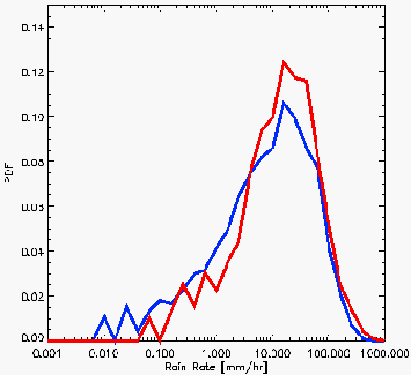

Figure 1. Histogram comparing 3-hourly 0.5° by 0.5° rain rates from the Kwajelein radar (blue) with coincident values from the TMPA research product (red) in 2001. Taken from Huffman et al. (2006).

CHAPTER FOUR

TROUGH INTERACTION DIAGNOSTICS

Following Molinari and Vollaro (1989) and Hanley et al. (2001), the ECMWF data are bi-linearly interpolated to TC centered cylindrical grids in a Lagrangian reference frame with radius and azimuthal resolutions of 50 km and 5º, respectively. In a manner similar to Lonfat et al. (2004), the mean TC TMPA estimates are binned into a storm-following grid with 50-km wide annuli spacing, centered on the storm out to the 1000 km radius. Due to the effects of vertical wind shear during a TI, precipitation data are analyzed in a shear-vector relative coordinate system and further binned into quadrants based on the direction of the shear vector, with the zero azimuth line pointing down-shear. A weighted mean six-hourly precipitation estimate centered on each ECMWF time step is computed ($0\text{.}\text{25}p_{t−1}+0\text{.}\text{50}p_{t}+0\text{.}\text{25}p_{t+1}$) to allow for inclusion of additional satellite microwave overpasses of the TC in the analysis. By using three-hourly time steps to produce mean six-hourly rain rates, the large errors inherent at the finest temporal resolution are reduced.

4.1 Vertical wind shear

The vertical wind shear is calculated using storm relative, area-weighted azimuthal mean Cartesian wind components at the centers of 100-km wide annuli (i.e. 50 km, 150 km, etc) out to a 500 km radius from the TC center. The mean vector wind can be expressed as:

$\left\langle V\right\rangle =\frac{1}{A}\sum_{i=1}^{5}{\left\{V_{i}\right\}A_{i}}$ (3)

where $V$ is the vector wind, the subscript $i$ represents each annulus,$A_{i}$ are the areas of 100-km-wide annuli and $A$ is the area that environmental winds are affecting the vortex, 500 km, with the brackets denoting an azimuthal average. The storm-relative winds were computed by subtracting out the six-hourly storm motion vector, computed with the best-track data, from the ECMWF winds at each time step. The averaging procedure described in (3) provides for a measure of the ambient flow across the storm after removing a symmetric vortex (Hanley et al. 2001).
In tropical latitudes defined here as ≤ 20ºN, the upper and lower boundary on the shear vector calculation is taken to be 200 and 850 hPa, respectively. Poleward of 20ºN, the cap on most convection is controlled by the tropopause, which can vary substantially in the vicinity of approaching troughs (Bluestein 1993). As a result, the 200 hPa pressure surface can sometimes be found lower than the tropopause in mature warm-core systems at large distances from an approaching trough. However, in the majority of TI cases where the tropopause dips downward across the jet due to the poleward increase in static stability, the 200 hPa pressure surface is located in the stratosphere (Bluestein 1993). As a result, using the 200 hPa pressure surface can introduce errors into the magnitude and more importantly, direction of the vertical wind shear. To ameliorate this effect, the ECMWF winds were interpolated to the height of the tropopause, defined here as the 2.0 PVU surface (Hakim and Canavan 2005; Waller 2006). The mean height of the tropopause produced by this method varied between ~150 - 300 hPa with large gradients in the vicinity of approaching mid-latitude troughs. On average, changing the upper shear boundary to the tropopause altered the shear vector by 1.3 ms⁻¹ ± 1.1 ms⁻¹ in magnitude and 25° ± 40° in direction. To be complete, a sensitivity test on the lower shear boundary of 850 hPa was examined at both the ocean surface and the 925 hPa surface. A blended ocean surface wind product with a 0.50° resolution that utilizes data input from NASA’s QuikSCAT scatterometer along with a background field from ECMWF was used to analyze the sensitivity of the surface to the vertical wind shear. Details of the blended wind product are available in Morey et al. (2005), which used National Centers for Environmental Prediction (NCEP) instead of ECMWF data. A quite modest resolution of 0.50° was used for this portion of the analysis in order to coordinate with the radial resolution of the cylindrical grid (50 km). Changing the lower shear boundary from 850 hPa to the ocean surface altered the mean shear vector 2.5 ms⁻¹ ± 2.5 ms⁻¹ in magnitude and 40° ± 54° in direction. In addition, altering the lower shear boundary from 850 hPa to 925 hPa produced a mean shear vector change of 0.9 ms⁻¹ ± 0.7 ms⁻¹ and 11° ± 23°. The values presented on the mean change in the shear vector based on differing boundary levels contain large standard deviations which is typical for a highly variable quantity such as wind velocity. Table 1 summarizes the changes to the basic state (200 – 850 hPa) shear vector due to alterations in upper and lower boundaries. In order to help elucidate the importance of using the tropopause as the upper boundary when computing vertical wind shear in mid-latitudes, as well as testing the lower boundaries, sensitivity tests on the shear vector analyzed through changes in precipitation is presented below.
Figure 2 shows a summary of the sensitivities of differing upper and lower shear boundaries on the mean maximum precipitation within each quadrant of the storm. The values were computed as maximums (over time) in order to highlight the influence of convection and thus they represent an upper bound on sensitivity. The sensitivity differences presented in Fig. 2 are computed as:

$S_{d}=\left|P_{S}−P_{B}\right|$ (4)

where $S_{d}$ is the precipitation sensitivity difference, $P_{S}$ is the mean maximum precipitation calculated by changing either the upper (tropopause) or lower (surface and 925 mb) boundary ($P_{\text{200}−\text{SFC}},P_{\text{200}−\text{925}},P_{\text{TROP}−\text{850}}$) of the shear vector while $P_{B}$ represents the mean maximum basic state precipitation computed with standard shear vector notation ($P_{\text{200}−\text{850}}$). Figure 3 is similar to Fig. 2, only the values shown are sensitivity ratios computed as:

$S_{r}=\frac{\left|P_{S}−P_{B}\right|}{Palignl{\begin{aligned}B\end{aligned}}_{}}$ (5)

where $S_{r}$ is the precipitation sensitivity ratio expressed as a percentage. Figure 3 is presented only to allow for a more general evaluation of the shear boundary impacts on precipitation at each radius.
Utilizing the surface QuikSCAT winds as the lower shear boundary results in the largest sensitivities in all quadrants of the storm with maximum values > 5.0 mmhr⁻¹ to the left of the shear vector for $S_{d}$ (Fig. 2) and between ~ 40 – 60% in all quadrants for $S_{r}$ (Fig. 3). Inside of ~ 400 km, there is strong radial dependence of $S_{d}$ (Fig. 2) due to intense convection while outside of ~ 400 km radius $S_{d}$ is small with values ≤ 1.0 mmhr⁻¹ in all quadrants as a result of the dominant stratiform precipitation processes. No clear radial trend is apparent from the plot of $S_{r}$ (Fig. 3). The smallest sensitivity to the basic state precipitation is found using the 925 hPa lower shear boundary with the tropopause located in the middle between the sensitivities of the two lower shear boundaries. Tropopause sensitivities > 3.5 mmhr⁻¹ for $S_{d}$ in the inner core region of the down shear left quadrant (Fig. 2) and between ~ 20 – 50 % for $S_{r}$ in all quadrants (Fig. 3) show the importance of using this upper boundary when computing vertical wind shear in mid-latitudes. Table 2 presents a summary of$S_{r}$, computed as a radial mean for each storm quadrant and all shear vector boundary tests studied. Table 2 shows for example, that using the tropopause as the upper shear vector boundary can change the precipitation by an average of 29% in the convectively active down-shear left quadrant. Thus, the substantial values seen in Table 2 provide further evidence in favor of using the tropopause when computing wind shear. Choice of dynamic tropopause level (2.0 PVU in this paper) is expected to produce only minor modifications to the shear vector and precipitation sensitivities quoted in this section.
The shear vector boundary sensitivities shown in Figs. 2 and 3 are found to be consistent with the physics of a TC. Within the boundary layer and especially near the surface, frictional effects alter the mean wind and twist the shear vector, resulting in an inaccurate depiction of the displacement of the warm-core vortex (Molinari and Bourassa 2006, personal communication). Although the 925 hPa surface is more accurate than the surface in the shear vector calculation because of reducing frictional effects, for many systems this level will still be located within the boundary layer resulting in a mean wind subjected to spurious frictional deflections. As a result, the 850 hPa lower boundary physically makes the most sense to use in computations of vertical wind shear. Sensitivity to the height (pressure) of the lower boundary is relatively small, provided the near surface winds are avoided. The physical and analytical reasoning behind using the tropopause as the upper shear boundary has already been discussed, but it is worthy to reiterate that sharp vertical gradients in wind velocity near the tropopause can substantially alter the shear vector, especially with an approaching mid-latitude trough, resulting in significant changes to the mean precipitation. As a result, in the remainder of the paper, vertical wind shear is computed between 850 hPa and the tropopause.

4.2 Eddy Angular Momentum Flux Convergence (EFC)

Physically, the EFC is a measure of the TC outflow layer spin-up from the influx of cyclonic eddy angular momentum imparted from the trough into the TC cylindrical volume. Positive values indicate that the trough is approaching the TC with an increase in mean angular momentum, while negative values (which occur less frequently for reasons stated in section 3a) indicate the opposite scenario.
The EFC, following Molinari and Vollaro (1989), can be written as:

$−\frac{1}{r^{2}}\frac{¶}{¶r}r^{2}\overline{u_{s}^{'}v_{s}^{'}}$ (6)

where $u$ and $v$ are the radial and tangential velocity components, respectively, $r$ is the radius from the storm center, the primes indicate azimuthal mean perturbations and the subscript $s$ denotes storm-relative flow. Thermal wind theory links the jet maximum and hence momentum source approximately along the tropopause and therefore, the EFC was computed as a mean over the 300-600 km radial range on the same 2.0 PVU surface used to define the tropopause in the vertical wind shear computations (Bluestein 1993). Molinari and Vollaro (1989) and Hanley et al. (2001) indicate that EFC values computed at inner radii (i.e. 300 – 600 km) appear to best indicate the approach of a trough on the TC vortex. Following DeMaria (1992) and Hanley et al. (2001), a TI is deemed to occur when the EFC ≥ 10 (ms⁻¹) day⁻¹ for at least three six-hourly time periods with the beginning of the period classified as TI initiation. Only the first instance of a trough interaction found from the above process was analyzed in this study, due to 1) the relatively short best-track time series allowed by the TMPA and 2) to avoid potential complexities in the momentum-mass balance adjustment process of the vortex following a TI event (Pfeffer and Challa 1981). The term “enhancement” is defined in this paper as the difference in mean rain rate in a 24-hour window centered on TI initiation time. Molinari and Vollaro (1989) reported a high correlation between outer and middle radius eddy angular momentum fluxes and storm deepening rates 27 - 33 hours later. Although an inner to middle radial range of 300-600 km was used in this study, Hanley et al. (2001) determined that EFC computed over the 500-900 km range was similar to the 300-600 km range indicating that either one is sensitive to identifying TIs. An excitation of convection/precipitation within the storm core will precede pressure changes at the surface and thus, the enhancement term will be able to detect the vast majority of modifications in precipitation due to an import of eddy angular momentum from an approaching trough.

4.3 Storm Compositing

Figure 4 displays the satellite microwave coverage for the TMPA dataset from 1998 to the present. Due to the upgrade in the microwave constellation in 2000 with the addition of a third DMSP SSM/I (F-15) and the start of the AMSU-B series of satellites, TCs in the Atlantic Ocean basin between the years 2000-2005 were examined for inclusion in this study. In order to be included in the database, a TC had to meet the following criteria: 1) classification as a hurricane at some point in the storm’s life cycle 2) meeting the EFC determined numerical criterion for a TI described in the previous section and 3) TC center did not make landfall within ± 24 hours of TI initiation time. The final database produced by this method contained 12 storms between the years 2000-2005 of which a summary, outlining the dynamic and thermodynamic parameters, is presented in Table 3.
Storms over land were not considered due to the unreliable gauge network in high wind conditions as well as the complicating effects of topography on the evolution of precipitation (Serra et al. 2001). Without the influence of land, the problem of TC TI intensification and rainfall enhancement reduces primarily to the effects of EFC, vertical wind shear and MSE potential on the vortex. The statistics presented in this paper are intended to assist operational forecasters warning for flood potential when a TC experiences a TI and is approaching a coastline. In addition, the results provide quantitative insight into the necessary conditions for intensification of a TC vortex due to a TI through analyzing the precipitation enhancement.
An analysis of the microwave satellite coverage within the 24-hour window centered on TI initiation time of several storms revealed that satellite sampling was not biasing the enhancement of precipitation observed. For example, in Hurricane Alex’s (2004; presented in next section) 24-hour TI window, two full (completely covering storm) TRMM and four full SSM/I overpasses with one partial (not completely covering storm) SSM/I overpass were observed before TI initiation, while two full and one partial TRMM and four full SSM/I overpasses were observed after TI initiation. The satellite coverage presented above was typical for many storms and even though the coverage was not perfectly distributed about TI initiation time, the TMI/PR calibration mentioned in section 3b will minimize sampling biases. Thus, these results indicate that the enhancement of precipitation during a TI observed with the TMPA dataset is a function of the evolving storm structure and not of satellite sampling.

TABLE 1. Changes in the mean shear vector when testing upper and lower boundaries against the basic state (i.e. 200 – 850 hPa) shear vector for all time steps (~ 420). Format is time mean ± one standard deviation. Zero azimuth line points to the North.
 | Tropopause (vs. 200 hPa) | Surface (vs. 850 hPa) | 925 hPa (vs. 850 hPa)
Magnitude (ms⁻¹) | 1.3 ± 1.1 | 2.5 ± 2.5 | 0.9 ± 0.7
Direction (°) | 25 ± 40 | 40 ± 54 | 11 ± 23

TABLE 2. Summary of shear vector boundary sensitivity ratios analyzed through changes in mean maximum precipitation. Values are computed according to (5) and are expressed in %. Format is radial mean ± one standard deviation for each storm quadrant; down-shear left (DSL), down-shear right (DSR), up-shear left (USL), up-shear right (USR).
 | Tropopause (vs. 200 hPa) | Surface (vs. 850 hPa) | 925 hPa (vs. 850 hPa)
DSL | 29 ± 6 | 42 ± 9 | 17 ± 4
DSR | 40 ± 9 | 57 ± 8 | 22 ± 5
USL | 36 ± 13 | 52 ± 8 | 19 ± 5
USR | 38 ± 8 | 60 ± 15 | 26 ± 6

TABLE 3. List of storms used for composite analysis along with summary of dynamic and thermodynamic components. The latitude represents the TC center position at TI initiation time while the EFC, shear and MSE potential are expressed as a mean over the 24-hour period following TI initiation.
Storm | Begin/end time | Lat. at TI start (°) | EFC  (ms⁻¹) day⁻¹ | Shear  (ms⁻¹) |  | MSE (KJkg⁻¹)
Alberto 2000 | 0600 UTC 4 Aug  1200 UTC 22 Aug | 38.83 | 17.92 | 12.12 |  | 4.11
Isaac 2000 | 0000 UTC 22 Sep  1200 UTC 01 Oct | 33.65 | 22.51 | 15.88 |  | 14.38
Michael 2000 | 0600 UTC 17 Oct  1800 UTC 19 Oct | 30.88 | 17.69 | 12.84 |  | 15.51
Erin 2001 | 0600 UTC 02 Sep  1800 UTC 14 Sep | 37.07 | 16.43 | 8.78 |  | 9.91
Felix 2001 | 1200 UTC 11 Sep  1200 UTC 18 Sep | 32.10 | 21.78 | 11.10 |  | 5.77
Gustav 2002 | 1800 UTC 08 Sep  0600 UTC 12 Sep | 37.18 | 19.05 | 14.77 |  | 2.83
Fabian 2003 | 1200 UTC 28 Aug  0000 UTC 08 Sep | 37.45 | 37.72 | 10.78 |  | 3.20
Kate 2003 | 1800 UTC 27 Sep  1200 UTC 07 Oct | 24.80 | 26.60 | 18.27 |  | 11.84
TABLE 3. (Continued)
Storm | Begin/end time | Lat. at TI start (°) | EFC  (ms⁻¹) day⁻¹ |  | Shear  (ms⁻¹) | MSE (KJkg⁻¹)
Alex 2004 | 1800 UTC 01 Aug  0000 UTC 06 Aug | 32.10 | 16.07 |  | 8.56 | 10.76
Danielle 2004 | 0000 UTC 14 Aug  0600 UTC 21 Aug | 23.73 | 13.65 |  | 16.63 | 11.69
Karl 2004 | 0000 UTC 17 Sep  1200 UTC 24 Sep | 29.73 | 34.23 |  | 12.71 | 18.44
Ophelia 2005 | 0600 UTC 07 Sep  1800 UTC 16 Sep | 30.63 | 18.45 |  | 7.52 | 12.70
Mean |  | 32.35 | 21.84 |  | 12.50 | 10.10

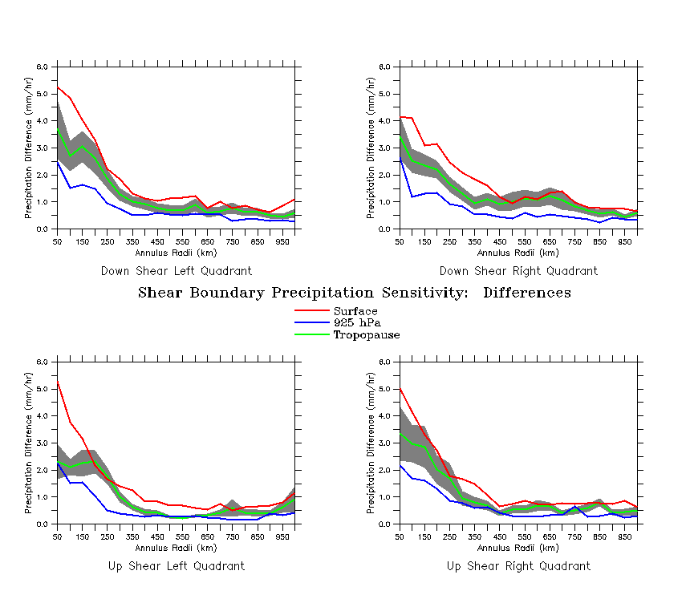
Figure 2. Summary of the sensitivities of differing upper (tropopause) and lower (surface, 925 hPa) shear vector boundaries on the mean maximum (over time) precipitation differences computed according to (4) in mmhr⁻¹ for all storms. Values are displayed in the four quadrants formed by the shear vector with the gray swath depicting the standard error of the mean for the tropopause.

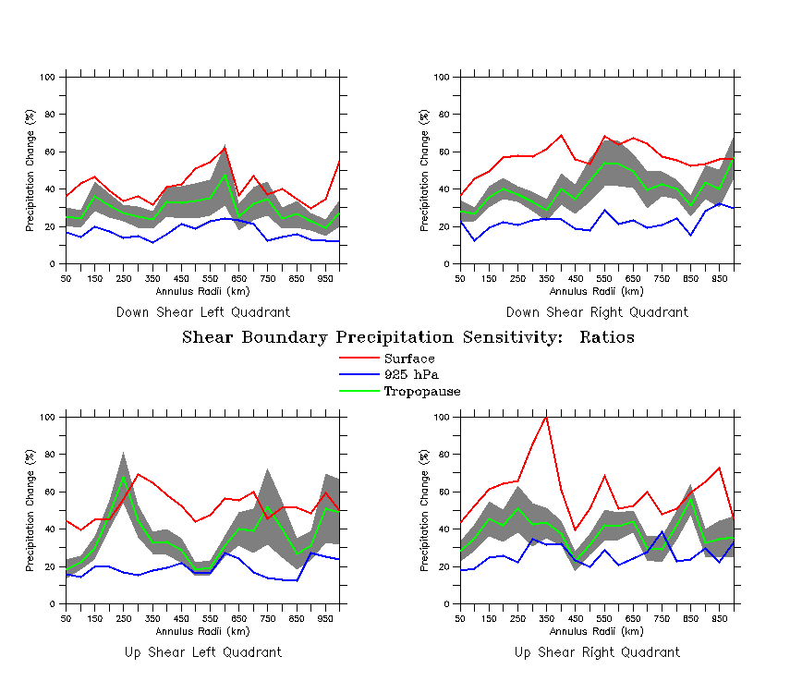
Figure 3. Same as in Fig. 2, only computed as a ratio shown in (5) and expressed as a percentage.

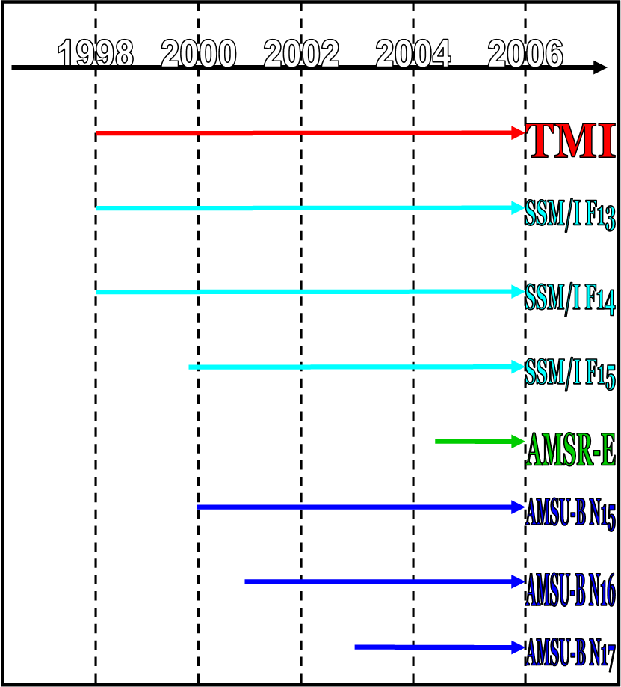

Figure 4. Microwave satellite data availability, up to the present day, used in the TMPA.

CHAPTER 5

RESULTS

5.1 Storm Case Studies

Two cases from the storm composites displaying opposite precipitation enhancements are shown for Hurricane Kate (2003) and Hurricane Alex (2004). The time series of EFC for Hurricane Kate (Fig. 5a) is shown using the TC best track positions described in section 3c. A period of elevated EFC with maximum values of 35 (ms⁻¹) day⁻¹ associated with the approach of an upper-tropospheric trough initiates at ~1800 UTC 28 September. This is a relatively rare example of how trough interaction termination time may have been possible to decipher: negative values of EFC (indicating eddy angular momentum flux divergence) near 1800 UTC 30 September seem to depict the movement of the trough away from the storm. However, the negative values are noisy and quite small, due to diabatic erosion of the trough’s PV anomaly, which makes interpreting TI termination time difficult. Due to the rarity of this negative EFC feature explained in section 3a along with the observed lag on storm deepening outlined in section 4b, the 24-hour window surrounding TI initiation was still employed. A second TI most likely would have been realized near 0600 UTC 6 October, however as noted in section 4b, only the first instance of a TI for each storm was analyzed.
Figure 5b displays Kate’s time series of vertical wind shear. A large increase in wind shear magnitudes starting at ~15 ms⁻¹ and maximizing at ~23 ms⁻¹ is evident in the 24 hours following TI initiation time. The general shape of the curve with increasing values following TI initiation time and decreasing values ~30 hours later is similar to the EFC (Fig. 5a). Although a linear relationship between EFC and vertical wind shear was not found to exist, in general increasing EFC is accompanied with increasing wind shear as the main body of the trough approaches the TC. The values of wind shear observed in Fig. 5b are quite large, inducing a tilt in the TC vortex in the down-shear direction, seen in the three-dimensional iso-surface of PV (0.8 PVU) at the time of TI (Fig. 5c). To aid in visualization, the iso-surface in Fig. 5c is colored by relative humidity with warm and cool colors denoting dry and moist air, respectively. In addition, Fig. 5c depicts the reflection of surface winds beneath the vortex, which can help assist in understanding the spin-up or spin-down of the system. The location of the mid-latitude trough with its associated dry air is seen clearly from Fig. 5c as it impinges on Hurricane Kate. This snapshot is a prime example of scale matching, seen from the similar PV horizontal scales of the trough and vortex. However, the scale matching appears to have occurred too late to reduce the negative impact of strong vertical wind shear and enable intensification, as the trough is observed very close to the core of the storm in Fig. 5c. Subsequent time steps revealed a spin-down of the surface winds and a general weakening of the vortex.
Figure 5d shows Hurricane Kate’s radius-time plots of precipitation for the four quadrants formed by the wind shear vector. The strongest precipitation occurs to the left of the shear vector with maximum coverage seen in the down-shear left quadrant and minimum coverage seen in the up-shear right quadrant of the storm. Focusing on the down-shear left quadrant, there is a significant change in precipitation in the 24-hour window surrounding TI initiation time. The swath of heavy precipitation with instantaneous values of ~13-14 mmhr⁻¹ before TI initiation shrinks substantially in size after TI initiation. The radial coverage of precipitation expands outward near the beginning and end of the time series, which corresponds well with the evolution of the EFC and wind shear plots. The extended radial coverage of precipitation is most likely due to displacement of the upper level warm anomaly and cloud condensate as a result of the strong wind shear.
The enhancement of precipitation for each quadrant of Hurricane Kate is shown in Fig. 5e. Overall, the largest enhancement activity takes place in the down-shear quadrants with a maximum negative enhancement of nearly -5.0 mmhr⁻¹ found at the 150 km radius in the down-shear left quadrant of the storm. The perturbations in the enhancement seen in the up-shear quadrants are quite small and confined to radii less than 150 km. The thermodynamic support for Kate, analyzed through the MSE potential (section 2a) was found to be 11.84 KJkg⁻¹ when the storm was located in the middle of the Atlantic Ocean at ~ 27° N. The MSE potential analysis indicates Kate had significant oceanic energy available to fuel and/or sustain convection during the storm’s TI episode. Despite the supportive thermodynamic environment, it is found that the TI with Hurricane Kate had a negative impact on convection and precipitation, most likely due to the large amounts of shear accompanying the EFC as the trough approached the TC core.
Figure 6a shows the time series of EFC for Hurricane Alex in 2004. A TI is found to initiate at ~2100 UTC 2 August with enhanced values of EFC lasting for a period of almost 36 hours. Maximum values of EFC only reach ~22 (ms⁻¹) day⁻¹, less than those found in Hurricane Kate. The corresponding vertical wind shear (Fig. 6b) has much lower (by ~ 10 ms⁻¹) mean values in the 24 hours after TI initiation time when compared with Hurricane Kate. In general, this result is to be expected, as the EFC values for Alex are lower than those of Kate. Due to the relatively weak wind shear, Alex’s vortex remained upright during the storm’s TI, shown by the three-dimensional PV iso-surface (1.1 PVU) snapshot interpolated to TI time in Fig. 6c. The horizontal scale of the trough in Fig. 6c is broader than that seen with Hurricane Kate; however, the main body of Alex’s trough is weaker and kept farther from the core of the storm during TI than observed with Kate. The trough thinning observed during the ~24 hour period after TI initiation is due to diabatic erosion of the trough’s PV near the core of the storm (see section 2b). The scale matching process with Alex (along with a generally weaker momentum source) seems to be more effective than with Kate, allowing the vortex to remain upright and moist during the TI. An upright, moist vortex provides important support to the influx of eddy angular momentum by concentrating the heating aloft and assisting in the development of eyewall buoyancy. Subsequent time steps beyond that in Fig. 6c depict an elongation of the TC PV tube and a concomitant spin-up of surface winds revealing the intensification of the storm.
The radius-time plot of precipitation shown in Figure 6d is similar to that of Kate in that the strongest precipitation occurs to the left of the shear vector with maximum instantaneous values and coverage in the down-shear left quadrant. There is a substantial increase in convection and precipitation rates in the 24-hours after TI initiation time in the down-shear left quadrant with instantaneous values greater than 14 mmhr⁻¹, which was not seen in Hurricane Kate. However, there is a general decrease in precipitation on the right side of the shear vector following TI initiation with minimum coverage observed in the up-shear right quadrant, which is consistent with the results presented on Kate.
Details on the enhancement of precipitation in Alex are shown in Figure 6e. A maximum positive enhancement of ~7.0 mmhr⁻¹ is observed in the down-shear left quadrant at the 100km radius with enhancement observed all the way out to the 600 km radius. In contrast, negative enhancement is observed on the right side of the shear vector in the down-shear quadrant with a maximum negative value of nearly -2.0 mmhr⁻¹ found at the 150km radius. Alex’s MSE potential was found to be 10.76 KJkg⁻¹ for a TC center position at ~ 34° N, located off the coast of the Carolinas in the vicinity of the Gulf Stream current. Thus, with lower values of shear, medium EFC and a large reservoir of oceanic energy available to the system, the TI with Hurricane Alex was found to have a large positive impact on convection and precipitation in the down shear left quadrant of the storm extending out to large radii from the TC center.
The TIs with Hurricanes Kate (2003) and Alex (2004) are shown to have a nearly opposite effect on the precipitation enhancement. The negative influence of large vertical wind shear observed during the TI of Kate acted to overpower the positive influence of strong EFC, resulting in negative precipitation enhancement in the down-shear left quadrant. In the case of Alex, the lower values of wind shear and moderate EFC appeared to allow for the positive influences of eddy angular momentum fluxes to dominate the evolution of the storm producing a large positive precipitation enhancement in the down-shear left quadrant. The MSE potential for both storms was very similar indicating a supportive oceanic thermodynamic environment was available to each system. As a result, the complexity of the comparison is minimized allowing for the dynamic components to determine the impact on the precipitation enhancement.

5.2 Composites

The mean precipitation enhancement for all twelve storms along with the swath of uncertainty for each measurement (expressed as the standard error, $s_{\bar{x}}={s_{x}}/{\sqrt{N}}$; Taylor 1982) is presented in Figure 7. Positive precipitation enhancements are seen to the left of the shear vector, with negative enhancements found to the right of the shear vector, consistent with previous studies of convective asymmetries (Reasor et al. 2000; Frank and Ritchie 2001; Corbosiero and Molinari 2002). The largest positive enhancements are found in the down-shear left quadrant of the storm, with a maximum at the 200 km radius of 1.4 mm/hr. The largest negative enhancements are found in the down-shear right quadrant, with a minimum at the 50 km radius of -1.5 mm/hr. The standard errors in precipitation are largest to the left of the shear vector and at inner radii due to the variability of intense convection within the TC core. The uncertainty decreases sharply with increasing radius as the area of the annuli grows and the precipitation becomes dominated by relatively slowly varying stratiform processes. It is important to note that while the mean enhancements in the down-shear left quadrant are positive, the standard errors encompass both positive and negative enhancements at radii ≤ 150 km due to the large variability from case-to-case as outlined in the previous section. Outside of 150 km, including the maximum at 200 km, the standard errors are reduced and encompass only positive enhancements. In order to provide for a more meaningful interpretation of precipitation enhancement, groups of storms with similar characteristics are analyzed as described later in this section.
To examine the sensitivity of TI initiation timing on the mean precipitation enhancement observed from Fig. 7, timing perturbations of ± 6 hours were added to the EFC determined TI initiation time for each storm. The resulting plot of mean precipitation change for all twelve storms in the down-shear left quadrant is shown in Fig. 8. The precipitation enhancement is most sensitive to changes in TI initiation timing exceeding ± 4 hours, where the mean precipitation change approaches 1 mmhr⁻¹ (increasing change with larger time perturbations) from ~200 km radius inward towards the TC center. The maximum mean precipitation change of ~1.6 mmhr⁻¹ is found near + 5-6 hours at the 50 km radius. The large change observed inside of 200 km radius is caused by intense core convection that varies with the fluctuating intensity of the storm. At radii further from the TC core, less intense stratiform rain rates result in a small sensitivity to TI initiation timing perturbations. Errors in estimation of the TI initiation timing can thus have potentially large impacts on the estimated storm precipitation enhancement within the TC core. For example, a change in precipitation of 1 mmhr⁻¹ due to a ± 4 hour timing perturbation produces a modification in precipitation of over 70% at the 200 km radius with potentially larger shifts at inner radii. Thus, if the TI initiation time is known to less than ± 4 hours from the EFC determined time, the precipitation enhancement can be determined within ~ 40-50% of the mean. Although this range is fairly large, it represents the upper bound on precipitation sensitivity to TI initiation timing at the innermost radii of a TC. Errors decrease sharply with smaller TI timing perturbations and for increasing radii. Precipitation is inherently difficult to measure and thus these results should still prove useful to operational forecasters.
The maximum seen at 200 km in the down-shear left quadrant is most likely due to a combination of two processes: (1) vertical wind shear displacing the warm anomaly, vorticity and convergence away from the TC center and (2) eddy momentum flux excitation of a secondary wind maxima that propagates inward to the TC core with time (Willoughby et al. 1982; Reasor 2000; Corbosiero and Molinari 2002). Upward motion is favored to the left of the shear vector due to: (1) the anomalous cyclonic vorticity induced by the shear and (2) the short orbital period of air parcels, as a result of strong tangential flow, leading to a displacement of the updraft from its origination point (Frank and Ritchie 2001; Corbosiero and Molinari 2002). Weaker vertical motions are favored to the right of the shear vector for opposite arguments. The large negative enhancements seen at the 50-150 km radii in the down-shear right quadrant are consistent with the physical explanations outlined above.
Scatter plots relating vertical wind shear magnitude to precipitation enhancement were found to be noisy for the relatively small number of storms examined in this study. In addition, four groups of storms (three storms within each group) organized by increasing shear magnitude were analyzed for trends in precipitation enhancement, but no clear signal was found due primarily to the small sample size within each group. In order to reduce noise and recover a clearer signal from the data, a thresholding technique that allows examination of the impact of increasing vertical wind shear on precipitation enhancement is employed in the next several figures. A storm is binned in a threshold if the mean wind shear magnitude in the 24 hours after TI initiation is less than or equal to a specified shear value ranging from 8 to 19 ms⁻¹. This process results in one storm included at the 8 ms⁻¹ threshold with a linear increase to include all twelve storms at the 19 ms⁻¹ threshold, shown in Fig. 9. The relationship between shear magnitude threshold and the maximum mean precipitation enhancement in the down-shear left quadrant is displayed in Fig. 10. Storms binned into lower wind shear thresholds are associated with higher maximum mean precipitation. However, as storms with higher wind shear values are included in the thresholds, the maximum mean precipitation decreases. The thresholding technique reveals a roughly linear relationship between vertical wind shear and maximum precipitation enhancement yielding a linear regression line, with correlation coefficient of 0.84, given by:

$\text{MPE}=−(0\text{.}\text{06}±1\text{.}5×{\text{10}}^{−4})\text{SM}+2\text{.}\text{75}±0\text{.}\text{03}$ (7)

where $\text{MPE}$ is the maximum mean precipitation enhancement for all storms contained within a shear threshold, $\text{SM}$ is the shear magnitude, and the error estimates are one standard deviation. Although many more cases are needed to develop a robust relationship, the relatively small number of cases presented here indicates that the precipitation enhancement is quite sensitive to shear magnitude, potentially providing operational forecasters with a semi-quantitative guide during TIs. The binning approach used herein to reduce the noise complicates the interpretation of this result for individual storms. The inclusion of storms with larger mean precipitation enhancements in the higher shear magnitude thresholds results in a substantially overestimated (insufficiently negative) slope in the regression line. Therefore, quantitative insight can only be found from the lower shear magnitude thresholds with qualitative information realized at higher thresholds.
Figure 11 synthesizes information on the relative roles of the EFC (positive influence), vertical wind shear (negative influence) and MSE potential (either positive or negative influence) on the precipitation enhancement in the down-shear left quadrant. In addition to the maximum mean precipitation enhancement, Fig. 11 also reports on the standard error of the mean at the location of the maximum enhancement which describes statistical uncertainty in the values presented. The precipitation enhancement has been shown to correlate well with wind shear magnitude thresholds seen in Fig. 10, however the relationship between precipitation enhancement, EFC and MSE potential was not found to be linear. Despite this conclusion, high values of MSE potential near 13.0 KJ/kg are associated with the largest precipitation enhancement of 2.38 mmhr⁻¹ although the wind shear magnitude was < 8.0 ms⁻¹ resulting in only one storm in the sample size. Similarly, higher values of EFC > 22.0 ms⁻¹day⁻¹ are linked to a precipitation enhancement of 2.23 mmhr⁻¹ with a larger sample size of four storms, although the wind shear was still fairly low at 11.0 ms⁻¹. It is important to note that a beneficial thermodynamic environment supported every storm with MSE potential ranging from 3 – 19 KJ/kg. Therefore, the problem of precipitation enhancement comes down to balancing the competing effects of TC vortex spin-up by eddy angular momentum fluxes and displacement of the warm-core through vertical wind shear. The results from this study indicate that in order to produce the largest precipitation enhancements (> 2.0 mmhr⁻¹), a medium strength TI with EFC values between 17.0 - 22.0 ms⁻¹day⁻¹, minimal vertical wind shear of < 12.0 ms⁻¹ and a generally positive MSE potential is needed. The standard errors in Fig. 11 are large at the first few shear thresholds due to a small sample size of only three storms. However, increasing from the 11.0 ms⁻¹ threshold, the standard errors are considerably smaller providing confidence in the maximum precipitation enhancement values. The slight increase in standard error seen at the 19.0 ms⁻¹ threshold is due to the inclusion of Hurricane Kate (2003), which was shown in the first part of this section to have a large negative enhancement. The analysis presented in Fig. 11 is a simplification of the relationship between the dynamics/thermodynamics and precipitation enhancement due to the thresholding technique used and the relatively small sample size studied. However, even if a larger sample size was analyzed, the results shown in Fig. 11 are expected to be similar due to the common underlying physics controlling convection and precipitation in TC TIs outlined in section 2.

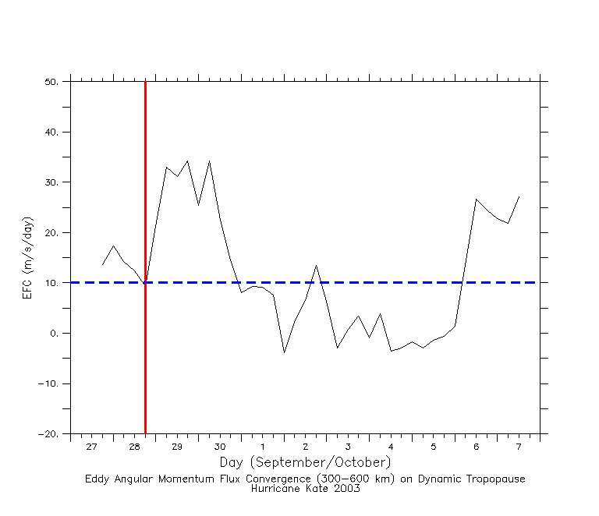
Figure 5a. Time series of EFC [(ms⁻¹) day⁻¹] on the dynamic tropopause for Hurricane Kate (2003). Red line denotes the time of TI initiation while the blue dashed line marks the 10 (ms⁻¹) day⁻¹ threshold used for determining TIs.

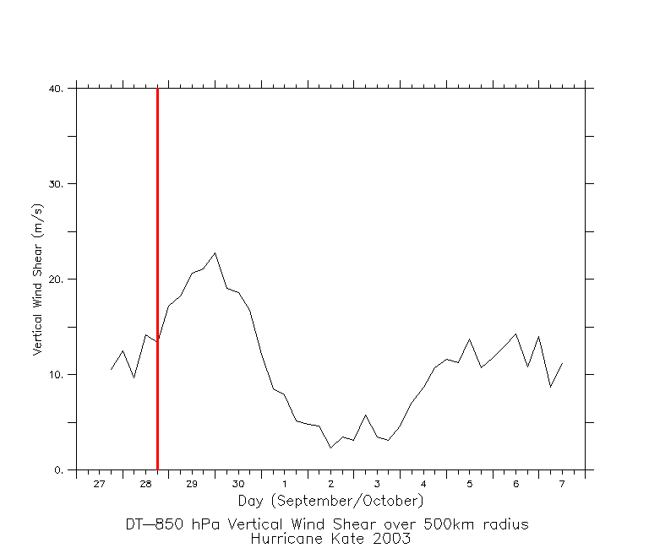
Figure 5b. Time series of vertical wind shear (Dynamic Tropopause — 850 hPa; ms⁻¹) for Hurricane Kate (2003). The red line has the same definition as in Fig 5a.

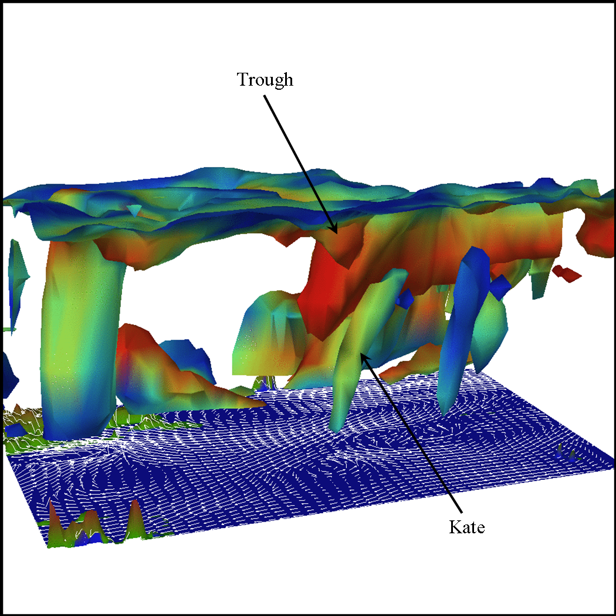
Figure 5c. Vis5D three-dimensional iso-surface of PV (0.8 PVU) for Hurricane Kate (2003) at the time of TI initiation (1800 UTC 28 September). ECMWF winds are overlaid on the surface for visual interpretation. The iso-surface is colored by relative humidity with warm and cool colors denoting dry and moist air, respectively.

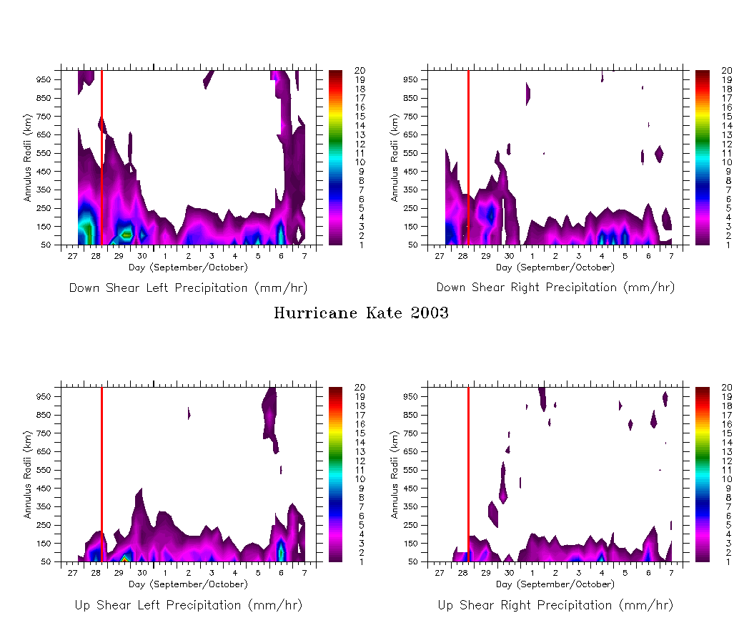

Figure 5d. Radius-time plot of precipitation (mmhr⁻¹) in the four-quadrants of Hurricane Kate (2003). The red line has the same definition as in Fig. 5a.

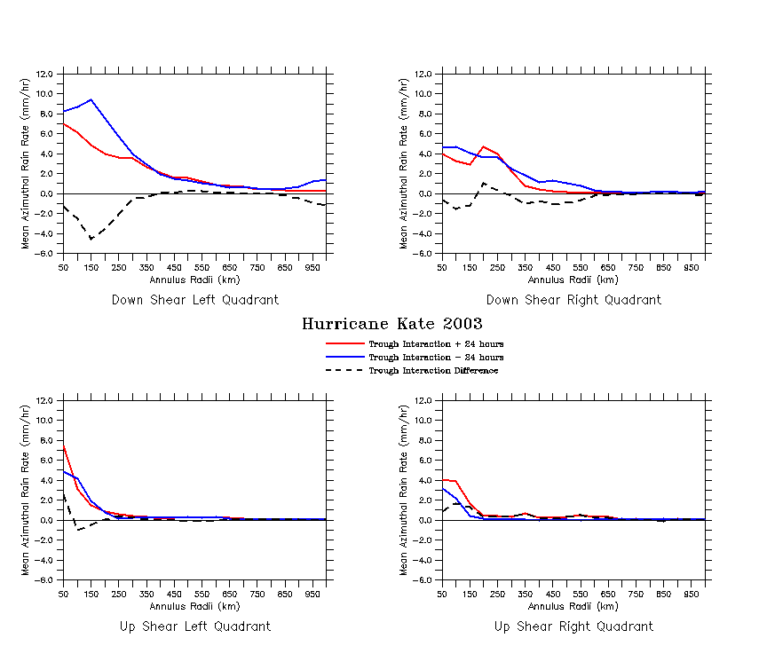
Figure 5e. Precipitation enhancements (black dashed line) in the four-quadrants of Hurricane Kate (2003). The mean precipitation in the 24-hours before and after TI initiation is shown in the blue and red lines, respectively with the thin black line displaying the zero line. All values are expressed in mmhr⁻¹.

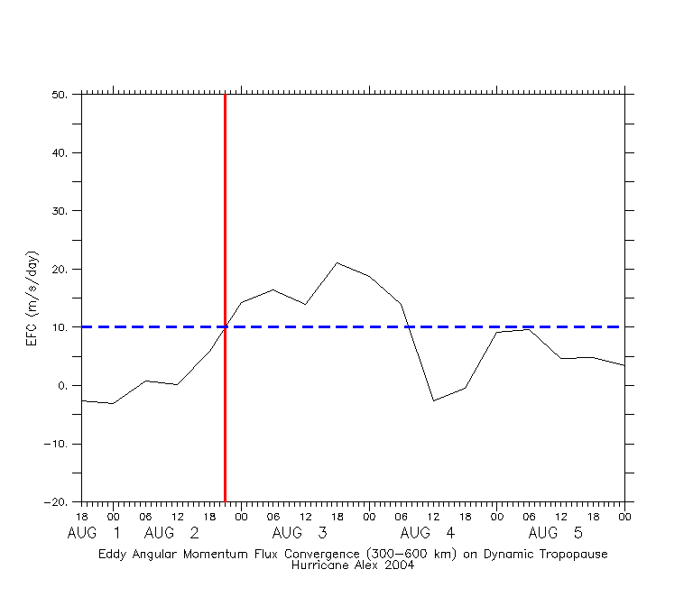
Figure 6a. Same as in Fig. 5a, only for Hurricane Alex (2004).

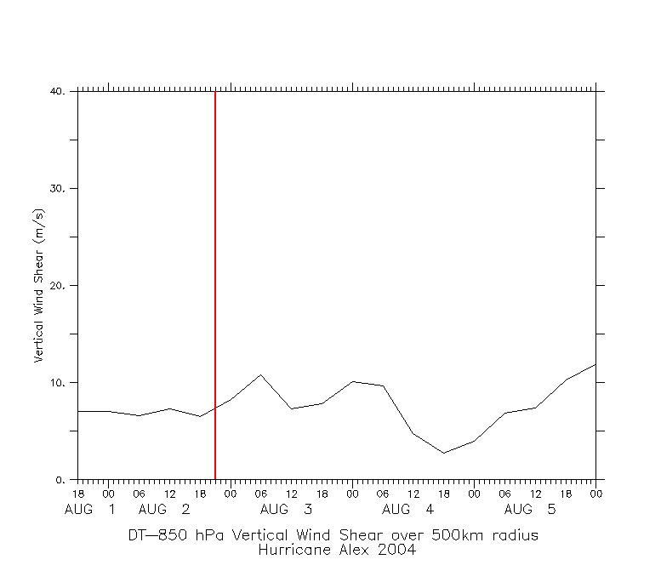
Figure 6b. Same as in Fig. 5b, only for Hurricane Alex (2004).

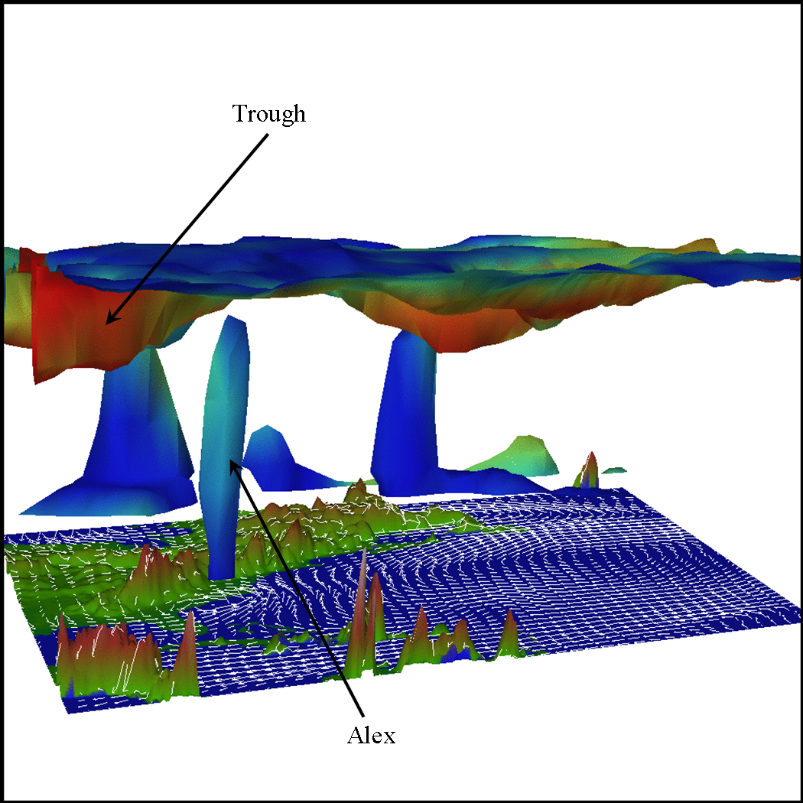
Figure 6c. Vis5D three-dimensional iso-surface of PV (1.1 PVU) for Hurricane Alex (2004) interpolated to the time of TI initiation (2100 UTC 2 August). All other plot details can be found in Fig. 5c.

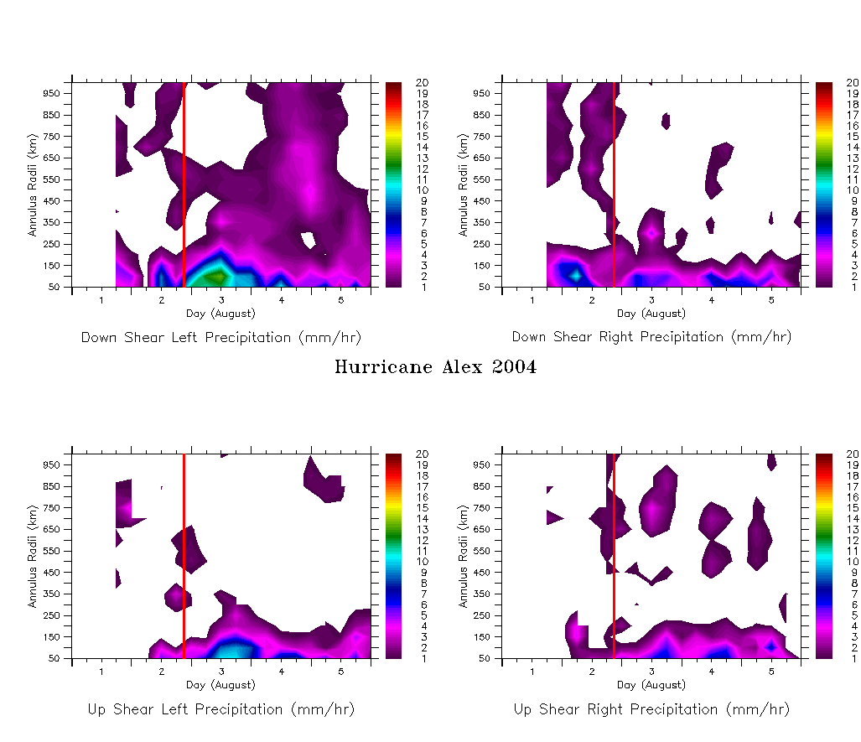
Figure 6d. Same as in Fig. 5d, only for Hurricane Alex (2004).

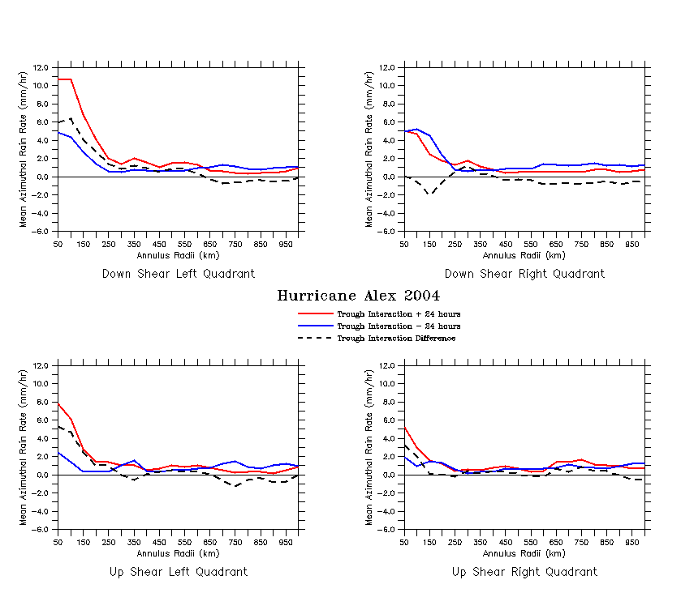
Figure 6e. Same as in Fig. 5e, only for Hurricane Alex (2004).

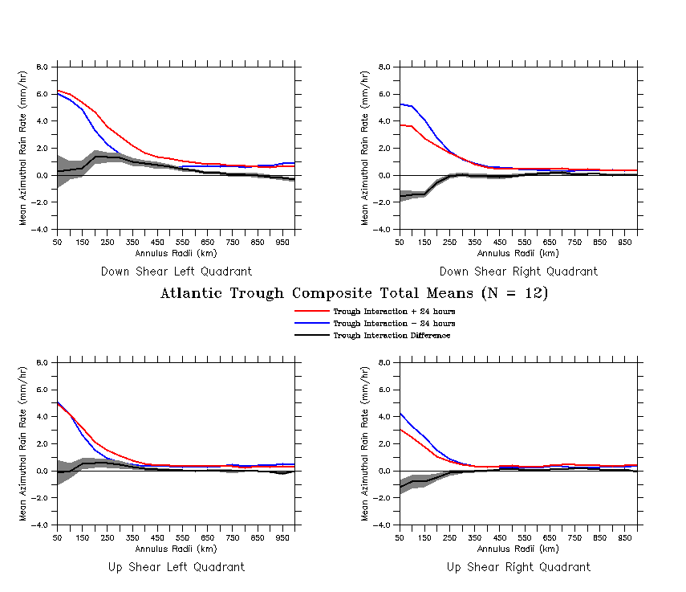
Figure 7. Composite mean (N=12) precipitation enhancements (thick black line). The blue and red lines depict the mean rain rates in the 24 hours before and after TI initiation, respectively. The gray swath shows the standard error of the mean enhancements and the thin black line displays the zero line. All values are expressed in mmhr⁻¹.

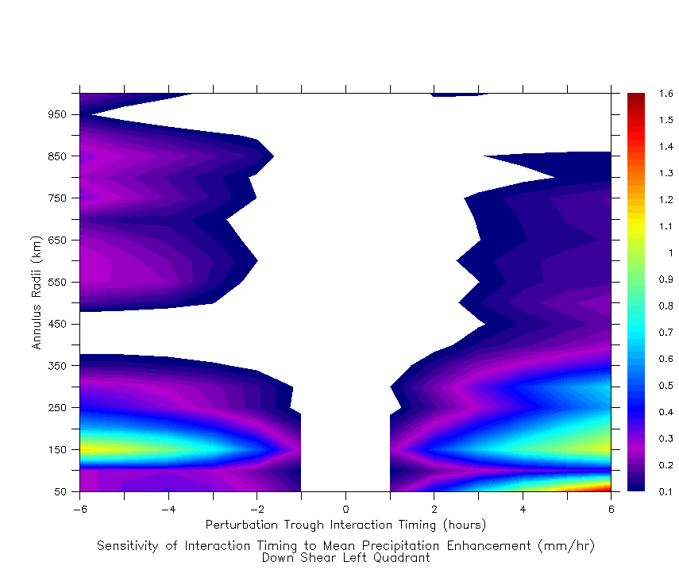
Figure 8. Sensitivity of EFC determined TI timing on the composite mean precipitation enhancements (mmhr⁻¹) in the down-shear left quadrant.

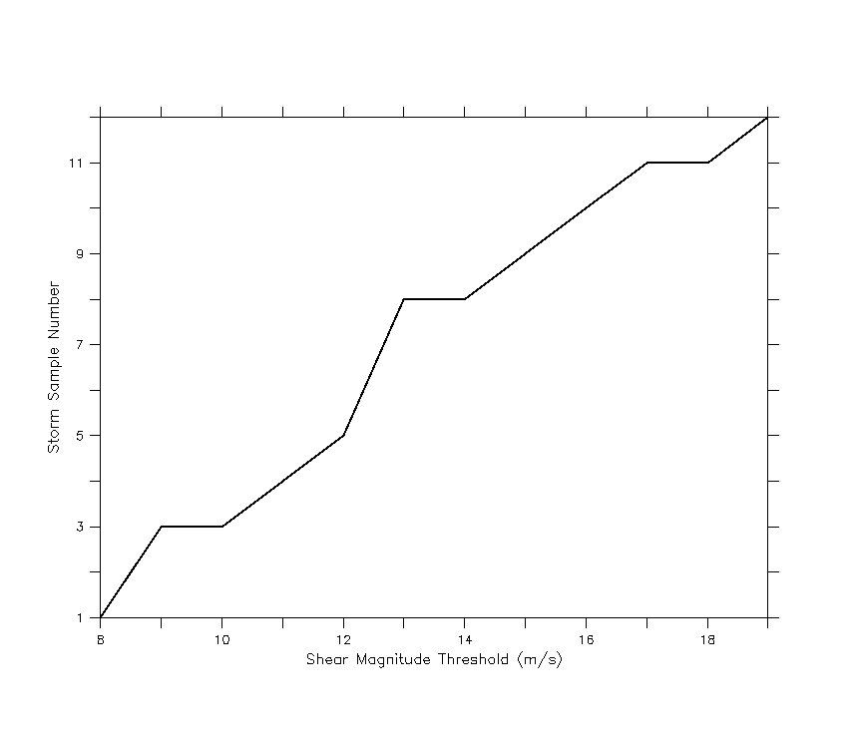
Figure 9. Storm sample number as a function of shear magnitude threshold (ms⁻¹) used for computing statistics on EFC, MSE potential and precipitation in subsequent figures.

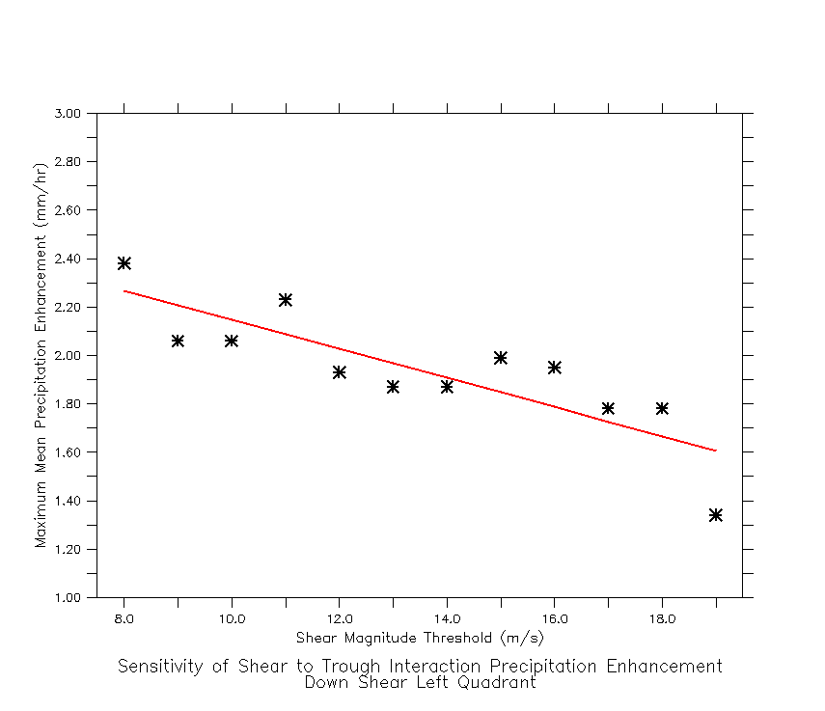
Figure 10. Scatter plot relating shear magnitude threshold (ms⁻¹) and maximum mean precipitation enhancement (mmhr⁻¹) in the composite down-shear left quadrant. Storm sample numbers can be found in Fig. 9. Linear regression equation with uncertainties is shown in (7).

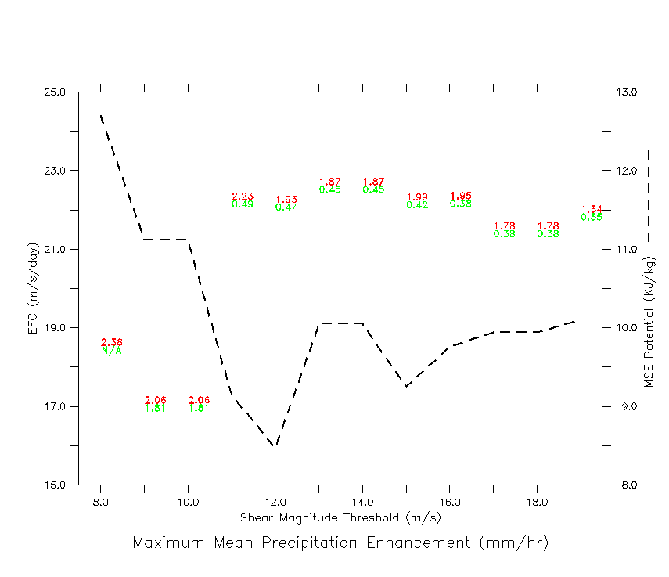
Figure 11. Scatter plot relating the maximum mean precipitation enhancements (mmhr⁻¹; red text) in the composite down-shear left quadrant to the shear magnitude threshold (ms⁻¹), mean EFC [(ms⁻¹) day⁻¹] and MSE potential (KJkg⁻¹). Green text is the standard error of the mean (mmhr⁻¹) reported at the location of the precipitation maximum. Storm sample numbers can be found in Fig. 9.

CHAPTER 6

DISCUSSION AND CONCLUSIONS

A diagnostic study analyzing the effects of TIs on the evolution of precipitation in TCs has been presented. A total of twelve TI cases in the Atlantic basin between the years 2000-2005 were collected based on (1) attainment of hurricane status at some point in the storm’s life cycle (2) meeting the numerical EFC criteria described in section 4b and (3) TC center did not make landfall within ± 24 hours of TI initiation time. Although the precipitation characteristics of TC TIs presented in this study only encompass storms over the ocean, the results provided herein can be used by operational forecasters when a TC undergoing a TI is advancing on a coastline. While a relatively small sample size is used for the composite analysis due to the time period of dense microwave coverage in the TMPA dataset, the storms analyzed displayed results that are qualitatively consistent with expectations, and provide a rough quantitative guide to physical thresholds.
The composites show that TIs produce the largest positive enhancements in the down-shear left quadrant of the storm with maximum mean rain rate enhancements of 1.4 mmhr⁻¹ at the 200 km radius. The largest negative enhancements are observed in the down-shear right quadrant with a minimum mean rain rate enhancement of -1.5 mmhr⁻¹ at the 50 km radius. The reasons for the strong asymmetries found across the shear vector axis are due to the displacement of updrafts from down-shear to down-shear left as a result of the small orbital periods in strong TCs (Franklin 1993; Frank and Ritchie 2001; Corbosiero and Molinari 2002). In addition, anomalous production of cyclonic vorticity, which provides for maximum vertical motion in the down-shear left quadrant and minimum vertical motion in the down-shear right quadrant, has also been attributed to the observed convective asymmetries (Frank and Ritchie 2001). The results depict little influence of TIs on TC precipitation structure outside of 400 km radius in all quadrants of the storm although the down-shear left quadrant sensitivity expands out farther. These findings are consistent with qualitative studies of the effects of vertical wind shear on a TC vortex where asymmetries in the convection and rainfall fields are organized about the shear-vector axis with largest concentration to the left of the shear vector (Frank and Ritchie 1999, 2001; Reasor et al. 2000; Corbosiero and Molinari 2002; Rogers et al. 2003). However, these studies did not analyze the sources of vertical wind shear, such as the approach of an upper-tropospheric trough with its associated momentum source, and therefore only provide a one-dimensional (negative effect) picture on the evolution of precipitation. Furthermore, the change in precipitation before and after the onset of shear has not been quantified, but should typically decrease due to dispersion of the warm-core and de-coupling of the boundary layer and mid to upper troposphere. Results from an analysis of the relative contributions of negative and positive effects on TC precipitation indicate that in order to produce the largest precipitation enhancements (> 2.0 mmhr⁻¹), a medium strength TI with EFC values between 17.0 - 22.0 ms⁻¹day⁻¹, minimal vertical wind shear of < 12.0 ms⁻¹ and a generally positive MSE potential is needed. Therefore, given supportive thermal influence from the ocean, the positive precipitation enhancements observed to the left of the shear vector are attributed to the influx of cyclonic eddy angular momentum and the resultant spin-up process described in section 2a.
Sensitivity tests, coupled with dynamical reasoning, on the upper shear vector boundary revealed the importance of using the tropopause instead of the 200 hPa surface when computing vertical wind shear in mid-latitudes, especially in the presence of upper-tropospheric troughs. On average, the tropopause was found to alter the shear vector by 1.3 ms⁻¹ ± 1.1 ms⁻¹ in magnitude and 25° ± 40° in direction from the traditional 200 hPa surface. Significant sensitivity on the mean maximum precipitation (convection) within all quadrants of the storm was found using the tropopause as the upper boundary on the shear vector with radial mean precipitation changes of 29 – 40 %. The standard lower shear boundary of 850 hPa was argued to be physically more reliable than either the ocean surface or 925 hPa due to its location above the boundary layer. Testing the ocean surface (QuikSCAT winds) as the lower shear vector boundary produced the largest sensitivities of all boundaries studied with radial mean precipitation changes ranging from 42 – 60 %. Within the boundary layer, friction alters the mean wind producing a physically unrelated twist in the shear vector resulting in large sensitivities on the precipitation. Therefore, the 850 hPa to tropopause layer is well suited for analyzing vertical wind shear in mid-latitudes.
The results of this paper are intended to not only provide a qualitative description of the evolution and enhancement of precipitation during a TC TI, but also a quantitative perspective as well. Figure 7 should help to give forecasters general quantitative guidelines on the effects of TIs with specific quadrant and radial regions of focus. Figure 11 provides information on the relationship between the positive and negative effects of a trough and the resulting precipitation evolution by analyzing groups of storms with similar vertical wind shear characteristics. If a larger sample size was studied, we would expect similar results in the relationship between EFC, shear and maximum precipitation enhancement due to the common underlying physics present in all TC TIs. Thus, although Fig. 11 is a simplification, the results should prove useful to operational forecasters and researchers alike. Furthermore, the precipitation enhancement results presented in section 5 are intended to establish an upper-bound or worst-case scenario during a TC TI that allows forecasters to warn for the greatest threat to life and property. Having knowledge of the relative amounts and locations (quadrant and radii) of precipitation enhancements associated with a TI case should provide forecasters with much needed information to improve on the deficiencies in the present state. In addition, quantitative details on the relative roles of vertical wind shear and EFC will allow for better diagnoses of “good” and “bad” troughs while providing physical insight into TC intensification from environmental forcing. Additional TI cases are needed in order to create more robust statistics and greater confidence in the precipitation enhancement results. As the TMPA dataset matures, more TC TI cases will become available providing the opportunity for a more thorough analysis of storms in varying ocean basins.

REFERENCES

Bluestein, H.B., 1993: Synoptic-Dynamic Meteorology in Midlatitudes: Observations
and Theory of Weather Systems, Vol. II. Oxford University Press, 594 pp.

Burpee, R.W., and M.L. Black, 1989: Temporal and spatial variations of rainfall near the
centers of two tropical cyclones. Mon. Wea. Rev., 117, 2204-2218.

Corbosiero, K.L., and J. Molinari, 2002: The effects of vertical wind shear on the
distribution of convection in tropical cyclones. Mon. Wea. Rev., 130, 2110-2123.

DeMaria, M., J.-J. Baik, and J. Kaplan, 1993: Upper-level eddy angular momentum
fluxes and tropical cyclone intensity change. J. Atmos. Sci., 50, 1133-1147.

——, 1996: The effect of vertical wind shear on tropical cyclone intensity
change. J. Atmos. Sci., 53, 2076-2087.

——, and J. Kaplan, 1999: An updated Statistical Hurricane Intensity Prediction
Scheme (SHIPS) for the Atlantic and eastern North Pacific basins. Wea. Forecasting,
14, 326-337.

——, and R. Tuleya, 2001: Evaluation of quantitative precipitation forecasts from the
GFDL hurricane model. Reprints Symposium on Precipitation Extremes:
Predictions, Impacts, and Responses, AMS, Albuquerque, NM, 340-343.

Elsberry, R.L., 2002: Predicting hurricane landfall precipitation: Optimistic and
pessimistic views from the symposium on precipitation extremes. Bull. Amer. Meteor.
Soc., 83, 1333-1339.

Emanuel, K.A., 1986: An air-sea interaction theory for tropical cyclones. Part I: Steady-
state maintenance. J. Atmos. Sci., 43, 585–605.

Frank, W.M., 1977: The structure and energetics of the tropical cyclone. I: Storm
structure. Mon. Wea. Rev., 105, 1119-1135.

——, and E. A. Ritchie, 2001: Effects of vertical wind shear on the intensity and
structure of numerically simulated hurricanes. Mon. Wea. Rev., 129, 2249-2269.

Franklin, J.L., S. J. Ford, S.E. Feuer, and F. D. Marks Jr., 1993: The kinematic structure
of Hurricane Gloria (1985) determined from nested analyses of dropwindsonde and
Doppler radar data. Mon. Wea. Rev., 121, 2433-2451.

Gray, W.M., 1968: Global view of the origin of tropical disturbances and storms. Mon.
Wea. Rev., 96, 669-700.

Hakim, G.J., and A.K. Canavan, 2005: Observed cyclone-anticyclone tropopause vortex
asymmetries. J. Atmos. Sci., 62, 231-240.

Hanley, D.E., J. Molinari, and D. Keyser, 2001: A composite study of the interactions
between tropical cyclones and upper tropospheric troughs. Mon. Wea. Rev., 129,
2570-2584.

Holland, G. J., and R. T. Merrill, 1984: On the dynamics of tropical cyclone structural
changes. Quart. J. Roy. Meteor. Soc., 110, 723-745.

Huffman, G.J., R.F. Adler, D.T. Bolvin, G. Gu, E. J. Nelkin, K. P. Bowman, E. F.
Stocker, and D. B. Wolff, 2006: The TRMM Multi-satellite Precipitation Analysis
(TMPA): Quasi-global, multi-year, combined-sensor precipitation estimates at fine
scales. J. Hydrometeor., (in review).

Lonfat, M, F.D. Marks Jr., and S.S. Chen, 2000: Study of the rain distribution in tropical
cyclones using TRMM/TMI. Preprints 24th Conference on Hurricanes and Tropical
Meteorology, AMS, Ft. Lauderdale, FL, 480-481.

——, ——, and ——, 2004: Precipitation distribution in tropical cyclones using the
Tropical Rainfall Measuring Mission (TRMM) Microwave Imager: A global
perspective. Mon. Wea. Rev., 132, 1645-1660.

Marks, F.D., Jr., 1985: Evolution of the structure of precipitation in Hurricane Allen
(1980). Mon. Wea. Rev., 113, 909-930.

Molinari, J., and D. Vollaro, 1989: External influences on hurricane intensity. Part I:
Outflow layer eddy angular momentum fluxes. J. Atmos. Sci., 46, 1093-1105.

——, and ——, 1990: External influences on hurricane intensity. Part II: Vertical
structure and response of the hurricane vortex. J. Atmos. Sci. 47, 1902-1918.

——, ——, and F. Robasky, 1992: Use of ECMWF operational analyses for studies of
the tropical cyclone environment. Meteor. Atmos. Phys., 47, 127-144.

——, S. Skubis, and D. Vollaro, 1995: External influences on hurricane intensity. Part
III: Potential vorticity structure. J. Atmos. Sci., 52, 2632-2644.

——, ——, ——, F. Alsheimer, and H.E. Willoughby, 1998: Potential vorticity analysis
of tropical cyclone intensification. J. Atmos. Sci., 55, 2632-2644.

Morey, S. L., M. A. Bourassa, X. Davis, J. J. O’Brien, and J. Zavala-Hidalgo, 2005:
Remotely sensed winds for forcing ocean models. J. Geophys. Res., 110(C10),
C10024, doi:10.1029/2004JC002338.

⎯⎯, M.A. Bourassa, D.S. Dukhovskoy, and J.J. O’Brien, 2006: Modeling
studies of the upper ocean response to a tropical cyclone. Ocean Dynamics. DOI
10.1007/s10236-006-0085-y.

Pfeffer, R. L., and M. Challa, 1981: A numerical study of the role of eddy fluxes of
momentum in the development of Atlantic hurricanes. J. Atmos. Sci., 38, 2393-2398.

Rappaport, E.N., 2000: Loss of life in the United States associated with recent Atlantic
tropical cyclones. Bull. Amer. Meteor. Soc., 81, 2065-2074.

Reasor, P.D., M.T. Montgomery, F.D. Marks Jr., and J.F. Gamache, 2000: Low-
wavenumber structure and evolution of the hurricane inner core observed by airborne
dual-Doppler radar. Mon. Wea. Rev., 128, 1653-1680.

Rodgers, E.B., and R.F. Adler, 1981: Tropical cyclone rainfall characteristics as
determined from a satellite passive microwave radiometer. Mon. Wea. Rev., 109, 506-
521.

——, J-J. Baik, and H.F. Pierce, 1994: The environmental influence on tropical
cyclone precipitation. J. Appl. Meteor., 33, 573-593.

Rogers, R., S.S. Chen, J. Tenerelli, and H. Willoughby, 2003: A numerical study of the
impact of vertical wind shear on the distribution of rainfall in Hurricane Bonnie
(1998). Mon. Wea. Rev., 131, 1577-1599.

Sampson, C.R., and A.J. Schrader, 2000: The automated tropical cyclone forecasting
system (version 3.2). Bull. Amer. Meteor. Soc., 81, 1231-1240.

Schubert, W.H., and J.J. Hack, 1982: Inertial stability and tropical cyclone development.
J. Atmos. Sci., 39, 1687-1697.

Serra, Y.L., P.A. Hearn, H.P. Freitag, and M. J. McPhaden, 2001: ATLAS self-siphoning
rain gauge error estimates. J. Atmos. Oceanic Technol., 18, 1989–2002.

Shi, J.-J., S. W.-J. Chang, and S. Raman, 1997: Interaction between Hurricane Florence
(1988) and an upper-tropospheric westerly trough. J. Atmos. Sci., 54, 1231-1247.

Taylor, J.R., 1982: An Introduction to Error Analysis: The Study of Uncertainties in
Physical Measurements. 2nd ed. University Science Books, 327 pp.

Waller, J.S., 2006: An investigation of coherent tropopause disturbances using a high
resolution global model. M.S. thesis, The Florida State University. 61 pp.

Willougby, H.E., J.A. Clos, and M.G. Shoreibah, 1982: Concentric eye walls, secondary
wind maxima, and the evolution of a hurricane vortex. J. Atmos. Sci., 39, 395-411.

BIOGRAPHICAL SKETCH

Stephen Richard Guimond was born on July 16, 1981 in Cincinnati, Ohio to Dorrie and Richard Guimond. He has an older brother, David and a younger sister Lynette along with a pug named Sasha. Family is and always will be one of the most important aspects of his life. Growing up in ‘Tornado Alley’ (Kansas and Illinois) sparked his interest in not only meteorology and nature, but science in general. He has always loved to learn and explore his curiosity on why things are the way they are. He owes his work ethic to both of his parents, who work humbly and tirelessly through life.
Steve graduated from Iowa State University with a B.S. in Meteorology in May, 2004 and completed his first publication under the mentorship of Dr. Xiaoqing Wu. Dr. Wu was a great inspiration to Steve and taught him many of the analytical skills he maintains to this day. After looking back on the last few years, it is clear that Florida State University has been an excellent career choice to obtain a M.S. degree in Meteorology. Keys to his success were two internships with the Naval Research Laboratory in Monterey, CA where he was able to explore his own ideas on tropical cyclone research. The mentorship of Mr. Jeffrey Hawkins, Dr. Joseph Turk and the rest of the lab has made a lasting impression on Steve and opened up many doors that would not have been found otherwise.
Steve plans to continue on for a PhD in meteorology either at Florida State or the University of Wisconsin–Madison continuing to analyze hurricane dynamics from an observational perspective. He is interested in discovering new insights into tropical cyclone structure through the use of satellite and radar observations. The ultimate career goal for Steve is to either (1) become a professor at a University or (2) conduct research for a government laboratory.

