Climate Outlook and Precipitation Forecast for the Contiguous United States in 2006

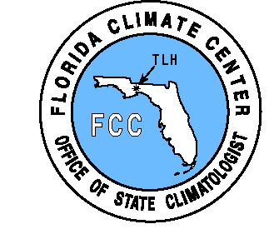


Dr. James J. O’Brien, State Climatologist

And

Mr. David F. Zierden, Assistant Research Climatologist

Center for Ocean-Atmospheric Prediction Studies

And

The Florida Climate Center

THE FLORIDA STATE UNIVERSITY

200 Johnson Building

Tallahassee, FL 32306-2840

May 5, 2006

Summary

Forecast Summary

- Neutral ENSO conditions (neither El Niño nor La Niña) have returned after a brief period of La Niña in the winter and early spring.

- Shifts in climate patterns are much weaker during the neutral phase than during El Niño or La Niña.

- Near-normal climate patterns are a common misconception of the neutral phase. A wide range of possibilities with little predisposition towards wet or dry is a better characterization of neutral climate patterns.

- In May and June, the predominant feature is a large area of increased probability of abnormally wet conditions in the Great Plains area.

- A multi-year drought is still affecting some of the Southwestern United States.

- Above normal rainfall and snow pack this winter have left conditions in the West and Pacific Northwest moister than any time in the last several years.

- Scattered heavy showers eased the fire danger over Florida in mid-May, and the Drought Outlook calls for more improvement as the thunderstorm season gets underway during late May and June.

Introduction

The natural variability of rainfall in the United States can disrupt planning of events affected by droughts, floods, and unusual rainfall. While “weather” may only be predicted a few days in advance, new understanding of “climate” variability caused by El Niño and La Niña permits probabilistic forecasts of more or less than normal rainfall. These forecasts, under certain conditions, have skill out to 6 months.
The El Niño-Southern Oscillation (ENSO) describes the fluctuation of sea surface temperatures along the equator in the eastern and central Pacific Ocean. The temperatures in this area can rise to over 10º F above normal at times (called an El Niño event), while falling to several degrees cooler than normal at other times (La Niña). The relationship between sea surface temperatures in the tropical Pacific Ocean and seasonal precipitation and temperature patterns in North America is now well-established and is used as a tool by NOAA’s Climate Prediction Center to forecast seasonal rainfall and temperature trends up to a year in advance.
El Niño and La Niña are the strongest drivers of the climate of North America, with impacts that vary across the different regions. These oceanic events shift the position of the jet streams across the continent, which act to steer the fronts and weather systems. Change the predominant tracks of the weather systems, and you change the resulting climate. Because the jet streams are strongest in winter months, the climate shifts are also more pronounced in the cold season. The Southeast U.S. experiences particularly strong climate shifts, with Florida feeling the greatest impacts. El Niño typically brings 30%-40% more rainfall and cooler temperatures to Florida in the winter, while La Niña brings a warmer and much drier than normal winter and spring. These forecasts, under certain conditions, have skill out to 6 months.
Drought conditions in many areas of the country can be triggered several months in advance by climatic conditions that affect the storage of water in such systems as mountain snow pack, soil moisture, surface water systems, and groundwater levels. Drought indices such as the Palmer Drought Severity Index attempt to track moisture through the hydrologic cycle and can be useful in indicating current dry conditions that may worsen over time.
In this report the Florida Climate Center will present and discuss current conditions through a variety of products that represent present moisture levels and water storage that could adversely affect moisture levels in the coming few months. A detailed precipitation forecast will also be presented for contiguous United States. The precipitation forecast will be presented graphically as a detailed month-by-month forecast that designates the probability of rainfall falling into four major classes (abnormally wet, extremely wet, abnormally dry, extremely dry). Finally, the climate forecast will be discussed in context with the current conditions in various regions of the country which we believe to be at an unusually high or unusually low risk of drought near the July Fourth holiday. In particular, we will concentrate on Florida as the current conditions and timing of the summer rainy season is of critical importance.

Current ENSO State

- La Niña is fading away, Neutral conditions (sea surface temperatures near normal) have returned for summer.

The first step in formulating the precipitation forecast is to assess the current and projected state of the tropical Pacific Ocean. Once the likely ENSO phase has been determined for the upcoming season, precipitation projections are made based on historical weather observations from similar ENSO phases.
In recent weeks sea surface temperatures in the tropical Pacific Ocean have returned to normal (Neutral) and should remain in the normal range for the rest of the summer. Neutral conditions generally correspond to variable temperature and rainfall patterns that average out to close to normal over the course of the season.
A weak La Niña, or La Niña - like conditions, began in November of 2005 and affected the climate of the Southeast through the winter and spring seasons. La Niña refers to colder than normal sea surface temperatures that develop over a broad area of the eastern and central tropical Pacific Ocean and return every 2 to 7 years. La Niña has strong impacts on the climate of the Southeast, bring warm and dry conditions in the winter and spring seasons and recent months have been no exception. This recent La Niña event was unique in the sense that it highly unusual for a cold (or warm event, for that matter) to form so late in the season.
La Niña is associated with warm and dry Fall, Winter, and Spring seasons in the Southeast U.S. Because of the late start to this event, December patterns were actually cold and moist here in the Southeast. However, January through April saw climate patterns establish themselves over the U.S. that are fairly typical of La Niña. The current drought-like conditions in Florida can be attributed to the La Niña - like conditions.

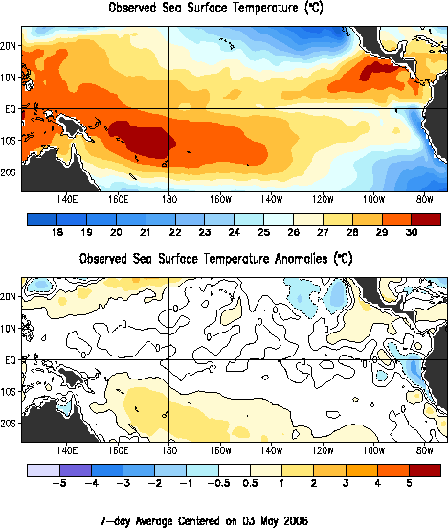

Recent Precipitation

Presented in the next two color plates are precipitation totals and departures from normal from the last 30 and 90 days. These plates show total precipitation, departures from normal, and percent of normal in separate maps. Rainfall surpluses are indicated in shades of green while areas with deficits are colored in brown.
Excess rainfall in the last 90 days has covered most of the western U.S. including California, Nevada, Utah, and the Pacific Northwest. More modest surpluses were recorded in the Midwest. More recently, the 30-day maps show more recent beneficial rainfall in the same areas of the western U.S. Plentiful rainfall has also fallen in the previously dry areas of Texas, Oklahoma, Arkansas, and Lousianna.
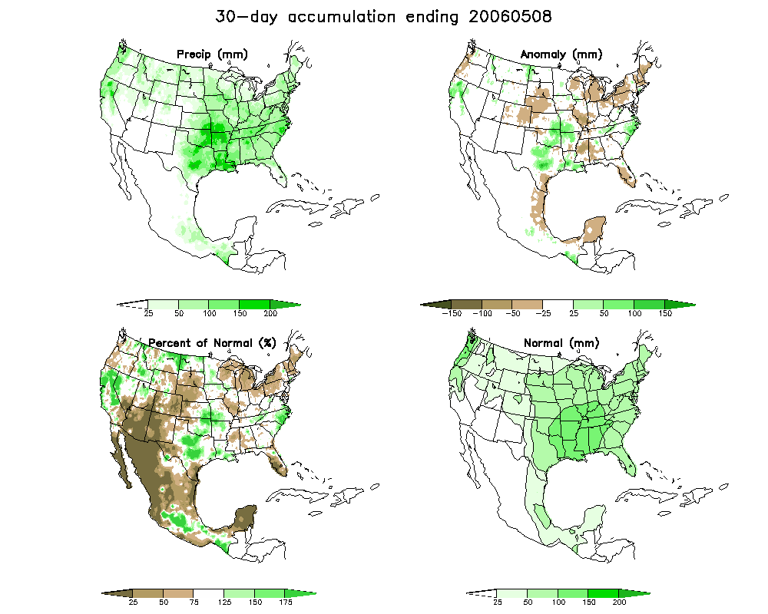

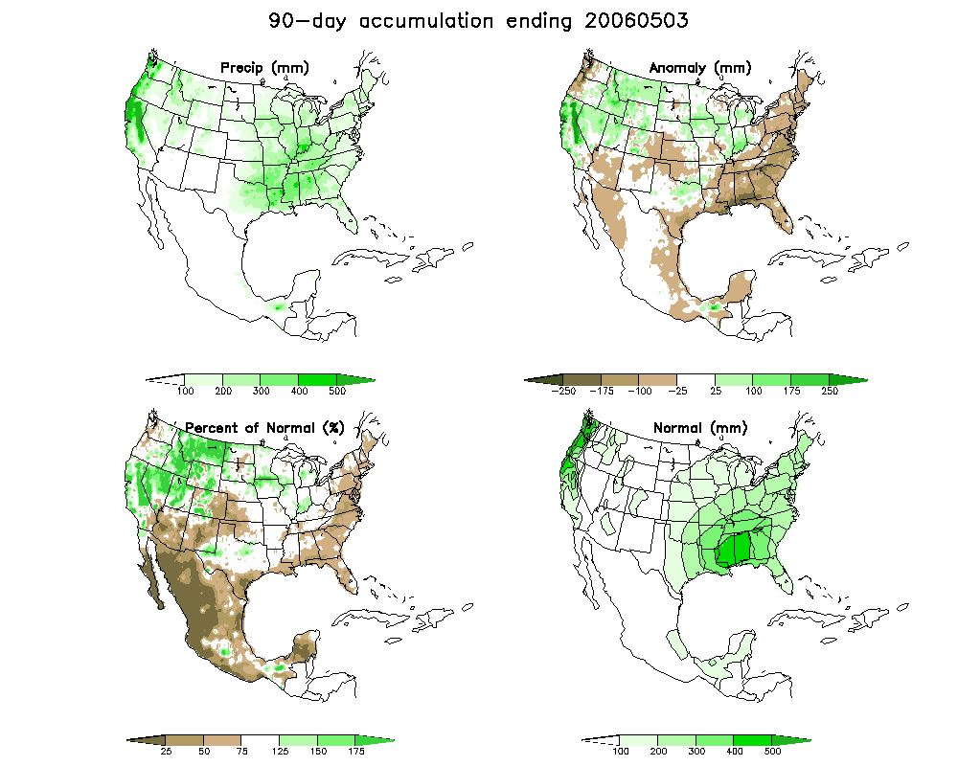

U.S. Drought Monitor

The National Weather Service and the National Drought Mitigation Center have recently teamed up to produce the U.S. Drought Monitor, a weekly graphical product that attempts to combine all aspects of drought into one easy-to-understand product. It is an assessment of drought conditions across the country based on past and recent precipitation, drought indices, soil moisture, surface and groundwater storage, and local impacts. The seasonal drought outlook is an extension of the Drought Monitor and shows which areas of the country are expected to see improvement, persistence, or worsening of drought conditions based on long-range forecasts and seasonal climate patterns.
The current Drought Monitor places most of the western U.S. as free of drought concerns due to the plentiful winter and spring precipitation and snowpack. States in good shape as we enter the summer season include Washington, Oregon, California, Idaho, Utah, and Nevada. The Mississippi valley has also experience plentiful rainfall and has no concerns at this time.
The Drought Monitor map also highlights the regions of greatest concerns. The driest areas right now are the Texas and Oklahoma panhandle regions, extreme south Texas, the Colorado front range, and the desert Southwest. Much of this dryness is a continuation of a multi-year precipitation deficit and prolonged dry conditions.
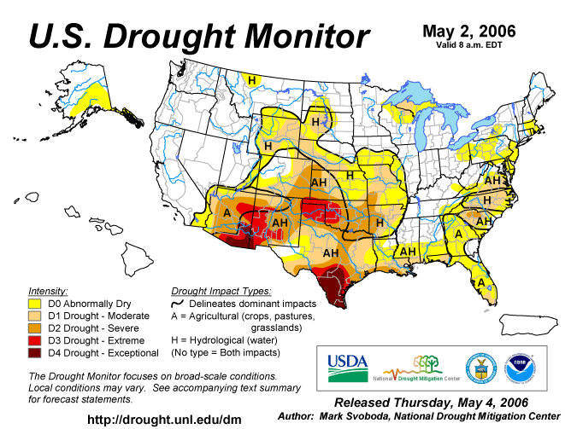

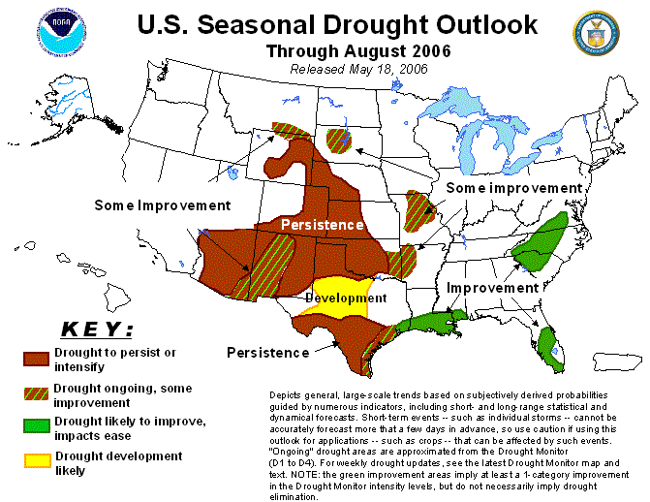
Palmer Drought Severity Index

A wide range of drought indices have been developed that attempt to track moisture surpluses or deficits over time and more specifically, how they impact all or part of the hydrologic cycle. Some indices are more indicative of recent rainfall and include the crop moisture index and the Keetch-Byram Drought index. Others react to rainfall over longer time periods and are more representative of hydrologic drought. Of these, the Palmer Drought Severity Index (PSDI) is the most well-known and is frequently used for making policy decisions on water supply and demand issues. The PSDI has well documented shortcomings in some regions of the country (mountain west) and for many applications. Nevertheless, it is necessary to monitor the PSDI as it can have great implications in policy decisions in some locations.
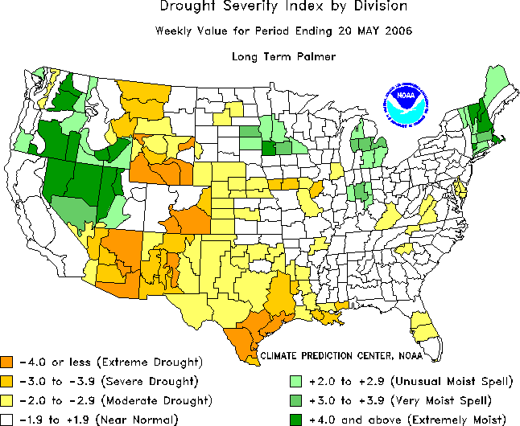

Precipitation Forecast Methodology

Given our understanding of El Niño and La Niña and their associated climate shifts, it is possible to make projections of monthly precipitation amounts up to a year in advance. The Pacific Ocean has a tremendous capacity to store heat, and changes in ENSO State are slow to occur. It is this “memory” that provides our predictive capability.

This report utilizes new method of climate forecasting developed at the Florida Climate Center based on historical data and their probability distributions. Hence, the forecast products are probabilistic in nature, and address the chances that precipitation totals will fall within a specific range, rather than predicting just one value.
In previous climate studies assessing the impacts of ENSO on temperature and precipitation, we have used the Japan Meteorological Agency (JMA) index and their definitions of El Niño and La Niña to categorize the different regimes. A list of El Niño, La Niña, and neutral years using the JMA classification is given below. Since 1948, there have been 12 El Niño’s, 13 La Niña’s, and 27 neutral years. More information on the JMA index can be found at: http://www.coaps.fsu.edu/research/jma_index1.shtml

El Niño, La Niña, and Neutral Years

El Niño Neutral La Niña
1951 1949 1980 1950
1958 1951 1981 1955
1964 1953 1982 1956
1966 1954 1984 1957
1970 1959 1986 1965
1973 1960 1990 1968
1977 1961 1991 1971
1983 1962 1993 1972
1987 1963 1994 1974
1988 1967 1995 1976
1992 1969 1996 1988
1998 1975 1997 1999
2002 1978 2001 2000
1979 2003

Let us take a close look at January precipitation in Florida’s climate division 4 as an example. To fully understand the method, we first need to examine the probability distributions associated with El Niño and La Niña. Over 100 years of historical January precipitation is divided into three groups, El Niño, La Niña, and neutral. Then, histograms are constructed for each of the three categories of January precipitation and are plotted on a common axis (see the figure below on the left). The peak of these graphs represents the mean January precipitation for each ENSO phase. However, the spread of these histograms shows that wide range of values is possible during each ENSO phase. The figure on the right conveys the same information, just presented in as the exceedence probability for each ENSO phase.

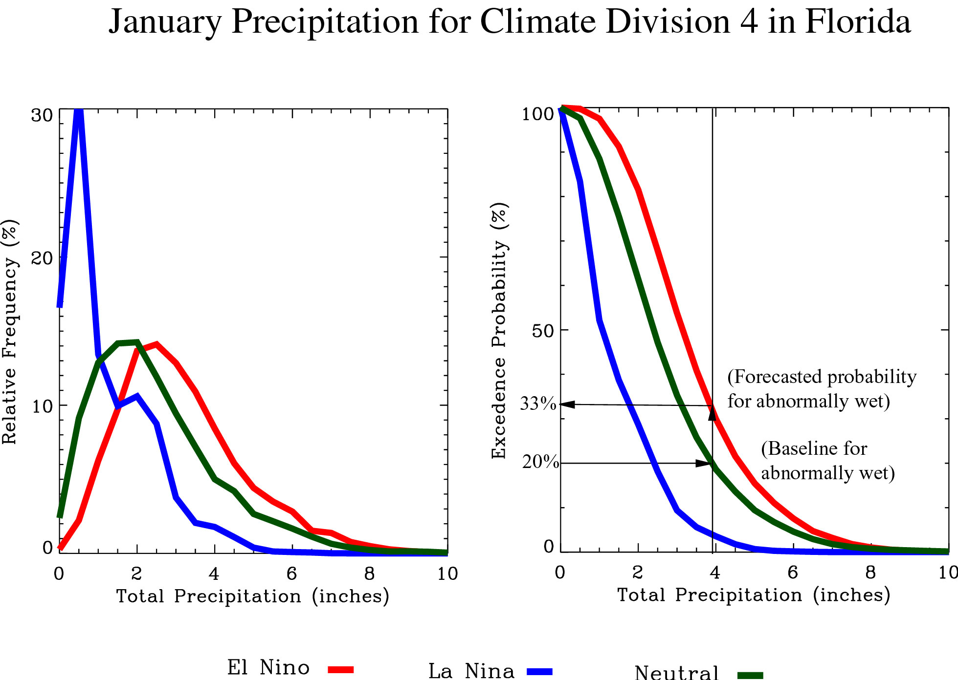

In our method of climate forecasting, we first establish a baseline based on the probability distribution for the neutral ENSO phase. From this distribution, normal precipitation is defined as the median plus or minus 30% (or around one standard deviation). Abnormally wet is defined as the highest 20% of occurrences, and extremely wet refers to the top 10%. Likewise, abnormally dry is designated by the lower 20% of occurrences and extremely dry by the lowest 10%. The precipitation amounts corresponding to the breaks between categories are determined from the neutral distribution. This is an important facet of our forecasting method, using the neutral distribution as a baseline. Most other climate forecasting centers use normal (or long-term average) as the baseline, which combines historical observations from all three ENSO phases.
The actual forecast addresses the shift in probabilities associated with each of the precipitation categories. This is accomplished by taking the values associated with each precipitation category and computing new probabilities base on the El Niño distribution. The excedence curves from Florida’s climate division 4 will be used as an example. The 20% baseline value (or cutoff for abnormally wet) is determined to be 3.9 inches from the neutral distribution. Following that amount to the El Niño distribution, we determine the probability of abnormally wet (3.9 inches or greater) is now 33% when an El Niño occurs. This climate division would be colored green (25%-35%) on the forecast map for abnormally dry in January. This technique is repeated for each precipitation category.
In this report, we use the method described above to forecast monthly probabilities for four precipitation categories (abnormally wet, extremely wet, abnormally dry, extremely dry). The forecast is made for each climate division in the contiguous United States for the months of January through June of 2004. The forecast is presented in map form, with each climate division colored to correspond to the probability of precipitation in the four designated categories. Yellow, orange, and red colors indicate and increased risk of dry conditions or a decreased risk of wet. Greens and blues correspond to and increased chance of wet conditions or a decreased chance of dry.

Precipitation Forecast Results

Given that the Pacific Ocean surface temperatures will remain near normal through the summer of 2006, any shifts in rainfall probabilities for the months of January through June are relatively weak. While El Niño or La Niña can increase the likelihood of abnormally dry or abnormally wet conditions by up to three times some parts of the United States, shifts in climate patterns associated with neutral conditions are much weaker. A common misconception is that neutral conditions favor seasonal rainfall and temperature patterns that are close to normal. In reality, a wide range of conditions are possible during the neutral ENSO phase with little predisposition towards wet, dry, warm, or cool. In the forecast for the coming six months, we did find some minor shifts in rainfall probabilities that may be useful for planning purposes. Also, the lack of a shift towards wet or dry conditions may be useful information as well.

Regional Discussion

General Climate Outlook for the Early Summer - Predicting the summer climate for the Southeast as hot and humid is a pretty safe bet. Neutral conditions generally correspond to variable temperature and rainfall patterns that average out to close to normal over the course of the season. Summer convective rains, usually characterized by frequent afternoon thundershowers, should begin later this month or early in June and gain momentum as the summer progresses. The convective rains usually arrive first in southern Florida, but quickly spread up the state and into Georgia and Alabama. With the return of the Pacific to neutral conditions, there is nothing preventing the thundershowers from arriving on time and in plentiful amounts. Summer temperatures are closely tied with precipitation patterns. Frequent rain and cloudiness tend to moderate temperatures, while clear skies and drier weather will allow aftenoon temperatures to rise. In Georgia and Alabama, most recharge of surface and groundwater storage takes place in the winter months. With summer evapotranspiration rates typically exceeding precipitation, expect soil moisture, surface, and groudwater levels to continute to decline.

Current Conditions - In spite of the limited strength and duration of the recent La Niña, January through April saw climate patterns over the Southeast that were fairly consistent with the typical La Niña response. Rainfall over Florida and coastal Alabama and Georgia generally ran 50%-75% of normal over the four month period. Average temperatures also ran 2 to 4 degree F warmer than normal over the three states during this time. The warm and dry conditions brought by La Niña superimposed on the traditional spring dry season in the Southeast (April through mid May) have left fields and forests quite dry as we enter critical planting, growing, and wildfire seasons.

Wildfire Outlook - Because of the prolonged warm and dry conditions that La Niña brings to the Southeast in the Winter and Spring months, it usually sets the stage for a very active wildfire season. On average, twice the normal acreage is burned in Florida alone during La Niña wildfire seasons. Timely rain events kept activity close to normal in February through March, but wildfire numbers and size have increased in the last few weeks, especially in southern Florida, in response to dry forest conditions. KBDI values are approaching 600 over most of Florida and southern Alabama and Georgia. Expect a continued threat for the next few weeks until the summer rains set in, a threat that could be worsened by ligtning strikes from scattered thundershowers.

Wildfire Risk Forecast

The wildfire activity potential forecast is based on the Keetch-Byram Drought Index (KBDI). The Florida Division of Forestry offers excellent primers on KBDI-based Drought classification as well as its use as an indicator of potential wildfire activity. Because of the chaotic nature of weather, all climate forecasts (including this wildfire threat forecast) are presented in terms of probabilities.
Weather data that drives the forecast are taken from hundreds of National Weather Service (NWS) cooperative observer sites in Florida, Georgia and Alabama. The large number of weather stations makes it possible to provide the forecast at a county level.
It has been shown that increased wildfire activity is linked with the deviation of the KBDI from seasonal normals. The KBDI tends to be at its peak in May, so values around 400 or 500 are not unusual at this time and do not indicate an increased threat. The substantial threat instead comes when KBDI values are 1 to 1.5 (or more) standard deviations (from these seasonal normals) above the seasonal average.
The wildfire threat forecast is presented in a series of color-coded maps showing the probability of the KBDI being in the following threat categories. .
- Severely dry (550 or above)
- Extremely dry (650 or above)
Since the KBDI is driven by daily weather and can change drastically based on one or more rainfall events, the maps show the probability of exceeding the threat level at least 7 days during the month, rather than for the month as a whole.
The forecast is based on both initial conditions (current KBDI values) and expected climate patterns associated with ocean temperatures in the tropical Pacific. For this reason, the forecast will be updated monthly throughout the season as conditions change in the field.

May 2006 KBDI Forecast
Severely Dry Conditions Extremely Dry Conditions
(at least 7 days at 550 or above) (at least 7 days at 650 or above)

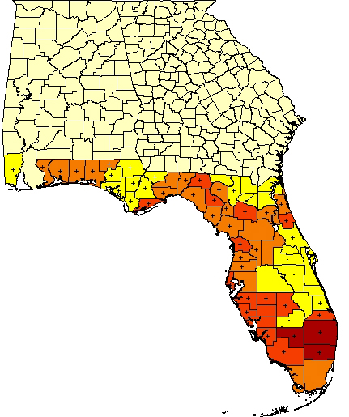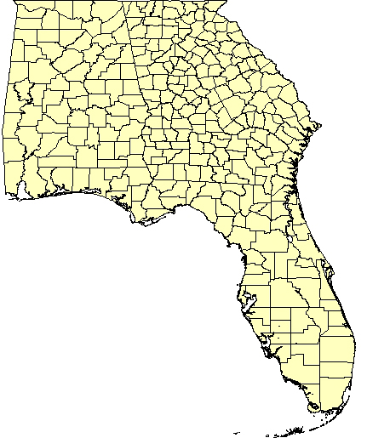
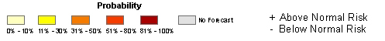

June 2006 KBDI Forecast
Severely Dry Conditions Extremely Dry Conditions
(at least 7 days at 550 or above) (at least 7 days at 650 or above)

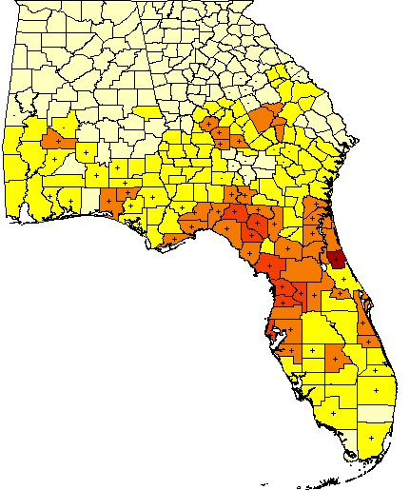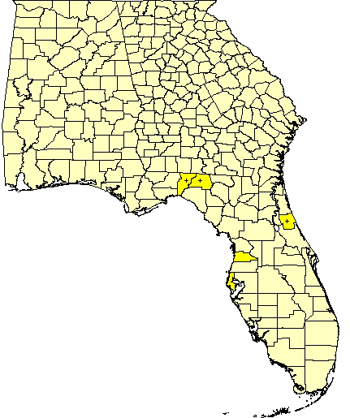

July2006 KBDI Forecast
Severely Dry Conditions Extremely Dry Conditions
(at least 7 days at 550 or above) (at least 7 days at 650 or above)

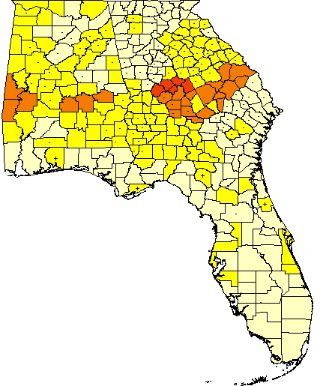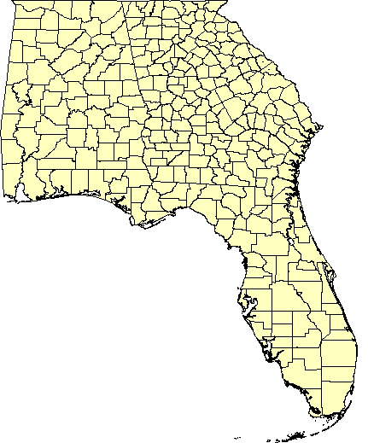

References

Brenner, James: Southern Oscillation Anomalies and Their Relationship to Wildfire
Activities in Florida, International Journal of Wildland Fire, 1, 73-78.

Bove, M. C. and J. J. O’Brien, 2000: PDO Modifications of U.S. ENSO Climate
Impacts, COAPS Technical Report.

Green, P. M., D. M. Legler, C. J. Miranda, and J. J. O’Brien, 1997. The North
American Climate Patterns Associated with the El Niño-Southern Oscillation.
COAPS Project Report Series 97-1.

Jones, C. S., J. F. Shriver, and J. J. O’Brien, 1999: The effects of El Niño on Rainfall
And Fire in Florida. The Florida Geographer, 30, 55-69.

Sittel, M. 1994. Differences in the Means of ENSO Extremes for Temperature and
Precipitation in the United States. COAPS Technical Report 94-2.

Swetnam, T. W. and J. L. Betancourt, 1990: Fire-Southern Oscillation Relations in the
Southwestern United States. Science, 249, 1017-1020

